

Southern California Edison
CS Re-Platform Project

CIM-CS-16 Manage Leads, Opportunities and Territories
Sales
Business Process Design
Version 1.5

Table of Contents
1 Business Process Overview 5
1.1 Current Pain Points for Southern California Edison 5
1.2 Responsible Parties 6
1.3 Document Control 7
1.4 Terminology 7
2 Business Process Design 9
2.1 Manage Leads, Opportunities and Territories Details 9
2.2 Process / Performance Improvement 41
2.3 Prerequisites and Inputs 41
2.4 General Assumptions 41
2.5 Business Process Hierarchy 41
2.6 Process Flows 42
2.6.2 Customer Care Sales Cycle 43
2.6.3 Economic Development Sales Cycle 47
2.6.4 New Construction Sales Cycle 51
2.6.5 Rebate Program Sales Cycle 55
2.7 3rd Party and SCE Legacy System Integrations 58
2.8 Data Elements 61
2.8.1.1 Manual Entry 61
2.8.1.3 Manual Entry 62
2.8.1.5 Manual Entry 64
2.9 Cloud for Customer (C4C) Integration 66
2.9.2 Processes 66
2.9.3 C4C Views 66
2.9.4 Interaction Records 66
2.10 Exception Management Requirements 66
2.11 Process Risks and Mitigation 66
2.12 Key Performance Indicators 66
2.12.2 Key Metric Definition 67
3 Controls, Regulatory Rules, and Security 68
3.1 Security Considerations 69
3.2 Custom Program/Transaction Codes 70
3.3 Custom Table/Transaction Codes 70
4 Technical Considerations 71
4.1 RICEF-W Assessment 71
4.1.2 Reports 71
4.1.3 Interfaces 71
4.1.4 Conversion 72
4.1.5 Extension/Enhancements 72
4.1.6 Forms 75
4.1.7 Workflows 75
4.2 IDEX Considerations 75
4.3 Production System Cut-over Considerations 75
4.4 Other Considerations 75
5 Change Management 76
5.1 Change Impacts 76
6 Requirements 78

This page intentionally left blank

Business Process Overview
The ‘Mange Leads, Opportunities and Territories’ Business Process Design (BPD) document defines the business process for managing the life cycle of Leads and Opportunities, and the creation and maintenance of Territories within Southern California Edison’s (SCE’s) SAP environment.
This BPD will cover the following processes:
- Customer Care Sales Cycle
- Economic Development Services Sales Cycle
- New Construction Sales Cycle
- Rebate Program Sales Cycle
- Territory Management
The Customer Care Sales Cycle is the process that will be used to capture a Business Partner’s (BP’s) intent to participate in or SCE’s intent to consider BP’s for non-rebate program initiatives, and tracking them through completion.
The Economic Development Services Sales Cycle is the process that will be used to capture a BP’s intent to participate in SCE’s programs and initiatives relating to assisting customers in services for business expansion, retention, or attraction within the SCE territory, and tracking them through completion.
The New Construction Sales Cycle is the process that will be used to capture a BP’s intent to participate in SCE’s programs and initiatives relating to new construction, and tracking them through completion.
The Rebate Program Sales Cycle is the process that facilitates the movement of projects through the Distributed Energy Resources pipeline from inception through completion. Documenting the sales cycle is critical for tracking goals and showing influence of projects. This process is focused on “Strategic Partner” and “Optimized Service” (i.e.: Assigned) customers who are serviced by Account Managers, Inside Account Managers, Account Coordinator, ‘DER Specialist’, ‘SCE Trade Pro Liaison’ and Field Engineers. However, the Rebate Program Sales Cycle is also available for “Self Service” business customers.
Lead Management in SAP Hybris Cloud for Customer (C4C) will be used to capture, distribute and qualify leads generated from a variety of channels including customer responses from a campaign, customer leads generated by SCE.com, leads from survey responses and customer interactions. Lead Management provides a streamlined link between marketing and sales to accelerate the process between first interest and sales.
Opportunity Management in SAP Hybris C4C will be used to create and qualify opportunities which are recognized possibilities for business projects. The opportunity makes up the framework for displaying sales projects through the full sales cycle and monitoring the success. An opportunity goes through the appropriate sales cycle that is characterized by different sales stages. As the opportunity progresses through the sales cycle, it begins to represent a potential sale until the sale is won or lost.
Territory Management in SAP Hybris C4C encompasses all activities that are required to create and maintain a hierarchy of sales territories and to delegate responsibility at each level of this hierarchy to the appropriate sales representatives. Territory assignments are used to determine the involved parties in business documents and to streamline the realignment process.

Current Pain Points for Southern California Edison
- Inability to convert a Prospect to a Customer. Non-customers are created as prospect business partners in the system. Once the prospect becomes a customer a second business partner is created resulting in duplicates. Audit conversion report requires a lot of information and is not feasible as a report.
  - A value is required in field ‘energy savings’ from a process standpoint, but not a mandatory field in system, so sometimes blank.
  - Products: New programs and the training involved usually rolls out by way of an email and a handout which can easily be overlooked.
  - Notification when new details or rule changes have been made on a specific program
  - Campaigns – Representative is no longer assigned to a customer and an email campaign goes out with the old representative on it.
  - Territory assignment gaps exist when a BP moves from assigned to self-service and the territory partner is not removed automatically from active transactions.
  - Territory Management is not notified when an Account Manager is moving to another position or leaving the company causing the territory and active transactions to not be updated in a timely manner.
  - Duplicate data entry for customer interaction and lead.
  - Data quality management from CSS to CRM (synchronized data not in sync).
  - Data quality for territories.
  - No change history on territories.
  - Creating a new territory, changing name of territory is a cumbersome process; requires IT intervention.
  - After territory change, reassigning open transactions to new account manager is a manual process (could be thousands of transactions).
- No consistent process for creating and working Leads and Opportunities. Each area / segment follows a different process.
- The annual territory re-assignment process is very complex and requires IT assistance to complete.
- When a territory changes, the re-assignment of Leads / Opportunities can be a manual process as there are gaps in the automated update.
- Some self-service customers (S4) are unclassified – meaning they are not assigned to the S4 segment.

Responsible Parties
Contact | Contact Person
Southern California Edison Business Process Owner | Ken Crebar
Southern California Edison Lead | Ernesto Valle
HCL Functional Lead | Naveen Kuchikulla
Solution Architect | Chitra Bose
Front Office or Back Office Lead | Pedro Costa
Subject Matter Experts | Michael Curley  Janine Aumont  Scott Hirth  Orlando Cisneros  Eva Flores  Erikka Foy
Key User Group | BCD

Document Control
Version | Description of Change | Date | Author
0.1 | Creation of Initial Version | 01/19/2018 | Naveen Kuchikulla
1.1 | Revised based on design discussions with SCE. | 05/02/2018 | Naveen Kuchikulla
1.2 | Documented the solution for the Demand Side Management Sales Cycle and New Construction Sales Cycle | 05/04/2018 | Naveen Kuchikulla
1.3 | Revised based on the feedback provided by SCE SME’s during the week of May 20th 2018. | 05/27/2018 | Naveen Kuchikulla
1.4 | Removed the design for potential incentive calculations. | 06/21/2018 | Naveen Kuchikulla
1.5 | Final version – Updated based on the feedback provided during the review period post walkthrough. | 06/27/2018 | Naveen Kuchikulla

Terminology
Term/Acronym | Definition and SAP Equivalent (if applicable)
SCE | Southern California Edison
APSE | Accelerated (or Axon) Project Support Environment
BMD | Business Master Data. The customer information which includes personal details, payment terms, dunning levels, billing rates and rate categories. The business master data objects are Business Partner, Business Agreement/Contract Account and Contract.
Customer | Any entity with a relationship with SCE. This term is usually used in reference to customers (both individuals and organizations) This can include employees and third party suppliers (banks and payment partners). SAP Equivalent is Business Partner (BP)
BPD | Business Process Design (or Document)
BPEM | Business Process Exception Management
BuAg | Business Agreement. The Business Agreement in CRM is equivalent to the Contract Account in CRB
CA | Contract Account
CRB | SAP Customer Relationship & Billing system. This is what is being implemented with the CSRP program.
CRM | SAP Customer Relationship Management
EAM | SAP Enterprise Asset Management
ECC | SAP ERP Central Component (SAP) - The core SAP modules (FICO, WM, SD, EAM, HR). This term is commonly used to refer to the existing SAP modules implemented at SCE.
ERP | SAP Enterprise Resource Planning
ICWeb or ICW | SAP Interaction Center Web Client
C4C | SAP Cloud for Customer Solution
IMG | SAP Implementation Guide - where configuration is performed
TMD | SAP Technical Master Data e.g. Connection Object, Premise and Device Location
BDEX | SAP add-on functionality to support the processing of BPEM Cases
Billing Cycle | Is a group of contracts to be billed together via date-driven or regional criteria, it controls the billing cycle and is linked to the Meter Reading Unit. SAP equivalent term is the Portion.
Billing Document | A document that outlines the charges incurred for energy consumption for a specific contract. During the process of Billing, a billing document is generated for each contract on a contract account.
Level Pay Plans | SAP equivalent term is Budget Billing. Budget Billing allows customers to pay regular equal amounts over a yearly period.
BWR | Basic Work Request. SAP equivalent is BPEM.
Channel | Data object in SAP that holds the interval data. Intervals can be kwh, price, factor, etc. SAP equivalent is Profile.
Clarification | A list of payments that could not be processed and require additional work in order to be posted.
Summary Billing | Standard SAP functionality that enables the invoicing of multiple Contract Accounts under one Parent Contract Account (Consolidated Summary Billing). SAP equivalent is Collective Billing.
Connection Object | Link between installation and postal regional structure. Usually a building, but can also be a piece of property or other facility, such as a fountain or construction site. The connection object corresponds to the functional location in plant maintenance (PM).
BCD | Business Customer Division
C&I | Commercial & Industrial
CP&S | Customer Programs & Services
DSM | Demand Side Management
GIAW | Government, Institutional, Agriculture & Water
IDSM | Integrated Demand Side Management

Additional terms may be found in APSE General Document # 32 CSRP Glossary

Business Process Design

Manage Leads, Opportunities and Territories Details
    - Customer Care Sales Cycle:
A Business Partner’s intent to participate in (or) SCE’s intent to consider BP’s for non-rebate program initiatives will be recorded in SAP Hybris C4C as Customer Care leads. Account Managers create Customer Care Leads on an individual basis or in mass. These types of leads can also be created in SAP Hybris C4C as follow-up transactions of sales tasks or service tickets or as a result of a campaign execution in SAP Hybris Marketing. Refer to the BPD: CIM-CS-15 ‘Manage Customer Segmentation and Campaigns’ for details on the creation of leads from campaigns in SAP Hybris Marketing and transferring them to SAP Hybris C4C.
Incoming leads will be assigned to the appropriate Account Management personnel based on pre-defined business rules for qualification and further processing. Refer to section 2.1.1.1 for the lead distribution rules.
Leads assigned to sales personnel will be updated repeatedly to establish and improve the level of interest represented by the lead and transform the lead to an opportunity. In each process iteration, the lead status and qualification level are updated as needed. Interactions with prospects or customers throughout the lead qualification process can be recorded using various types of activities. Refer to section 2.1.1.3 for details on Activity Management. Leads will eventually be set to ‘Qualified’ or ‘Declined’ status. If the status of the Lead is set to ‘Declined’, it marks the end of the transaction cycle.
Qualified leads can be converted to opportunities. A Customer Care Lead will be converted to a Customer Care Opportunity using the ‘Convert to Opportunity’ action on the lead transaction. All relevant information (i.e.: standard fields in SAP Hybris C4C that are common to Leads and Opportunities) will be copied to the target transaction. When a lead is converted to an opportunity, it remains in the system as a record. Converted leads cannot be changed or deleted, but follow-up items that arise from the lead can be processed as needed.
A Customer Care Opportunity goes through a cycle that is characterized by different stages. Specific activities are carried out in these stages. Interactions with prospects or customers throughout the cycle can be recorded using various types of activities. Refer to section 2.1.1.3 for details on Activity Management. A Customer Care project ends in SAP Hybris C4C with the Opportunity transaction, upon which its status will be set to ‘Won’ or ‘Lost’.

      - Lead Management:
Leads can be created in SAP Hybris C4C on an individual basis from the ‘Leads’ facet (Tab) of an Account, Contact or Individual Customer record, or from the ‘Leads’ work center. Leads can also be created in mass using the ‘Import from Microsoft Excel’ action on the ‘Leads’ work center.
Overview: The ‘General Data’ section on the ‘Overview’ facet (Tab) of the lead will contain the following fields:
Lead ID; Lead Description; Account; Primary Contact; Qualification; Status; Reason Code; Source; Campaign ID; Category; Owner; Marketing Unit; Note; Sales Organization; Distribution Channel; Division; Sales Unit; Start Date; End Date; Territory ID, Territory Name and Topics Covered.
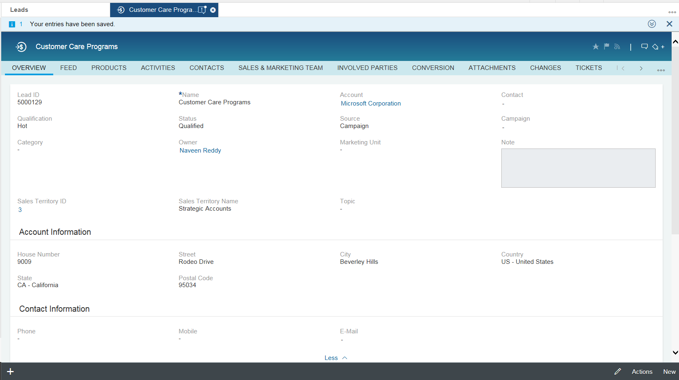
Figure 2.1.1.1.1 – ‘Overview’ facet (Tab) on the ‘Leads’ work center view
The ‘Category’ field on a Lead transaction will be used to categorize it as a ‘Customer Care’, ‘Economic Development Services’, ‘New Construction’ or ‘Rebate Program’ lead.
The ‘Source’ field on the Lead transaction will be used to capture the origin. Note: For a complete list of values that will be available for selection for this field, see Section 2.8.
The ‘Start Date’ of the Lead will be defaulted to the system date at the time of creation (i.e.: today’s date) and the ‘End Date’ will be defaulted to ‘Start Date’ + 30 days.
‘Utilities Contracts’ section will be added on the ‘Overview’ facet (Tab) of the Lead to support the assignment of multiple contracts to a lead. This solution will be implemented through an enhancement. Refer to the FS Document: E-CIM-CS-16 - ‘Enhance leads in SAP Hybris C4C with custom fields and business logic’ for more details.
Notes: Notes can be added to a Lead using the ‘Notes’ facet as shown in figure 2.1.1.1.2.
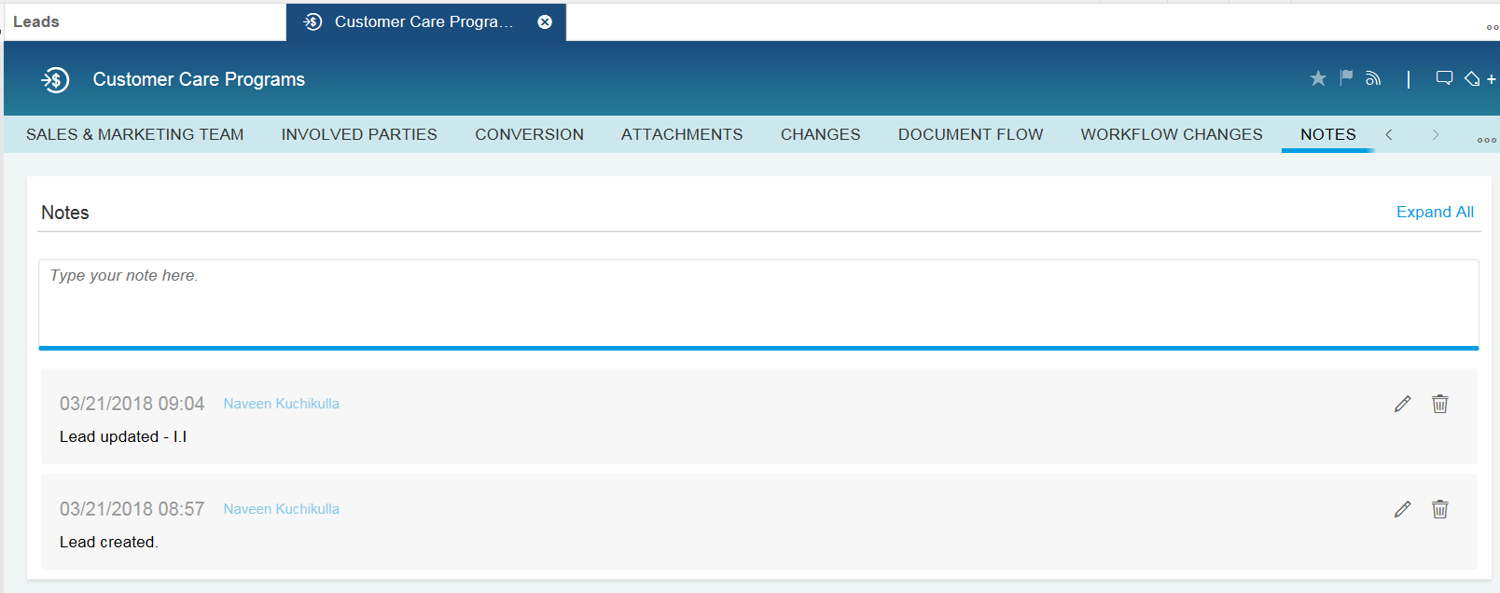
Figure 2.1.1.1.2 – ‘Notes’ facet on the ‘Leads’ work center view
Attachments: Attachments can be added to an Opportunity using the ‘Attachments’ facet (Tab) as shown in figure 2.1.1.2.2.
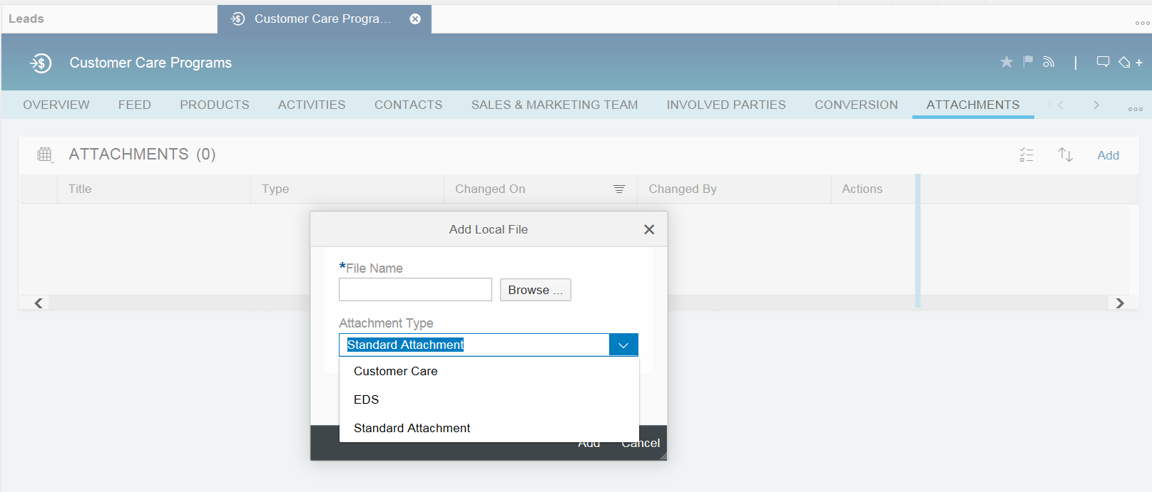
Figure 2.1.1.1.3 – ‘Attachments’ facet on the ‘Leads’ work center view
A Local File or a Web Link or a file from the Library can be added as an attachment. For Customer Care leads, ‘Standard Attachment’ will be defined as a Dropdown List value for the field: Attachment Type.
Change History: Change History for Lead attributes can be seen on the ‘Changes’ facet (Tab) as shown in figure 2.1.1.1.4. The following attributes of a Lead transaction will be captured in the Change History:
Attachment External Address Link, Attachment File Name, Attachment Title, Category, Contact Party Address, Contact Party ID, End Date, Item Description, Lead ID, Main Party, Name, Party Address, Party ID, Party Role, Priority, Product Category ID, Product ID, Qualification, Quantity, Reason Code, Reference Document ID, Reference Document Type, Source, Start Date, Status, Territory ID, Text, Unit of Measure and User Status.
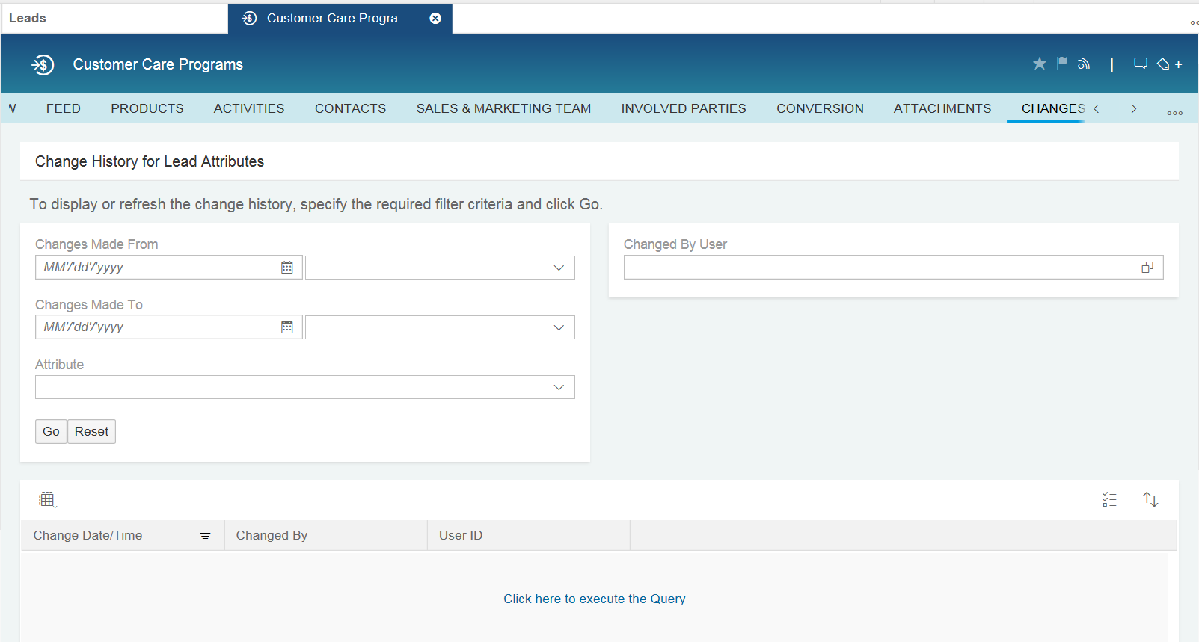
Figure 2.1.1.1.4 – ‘Changes’ facet on the ‘Leads’ work center view
Partner Determination: Leads will be distributed to employees based on their assignment to territories in Territory Management. Upon determination of the Sales Territory ID in a Lead transaction, the Business Partner assigned to the ‘Account Manager’, ‘Account Coordinator’, ‘DER Specialist’, ‘Inside Account Manager’ and ‘SCE Trade Pro Liaison’ and party roles of that territory will be copied to the corresponding party roles of the Lead transaction. Additionally, the following party roles will be available for manual maintenance in Leads:
- Auditor
- Economic Development Consultant
- Economic Development Analyst
- Engineer
- New Construction Representative
- Outreach Specialist
- SCE Analyst
- SCE Field Engineer
- SCE Pump Test Engineer
- Technical Coordinator
- Trade Professional
- Primary Facility Contact
- Design Team Member
- BCST Account Manager
- Agent

Lead Qualification: Upon the assignment of leads to sales personnel, these transactions are updated repeatedly to establish and improve the level of interest represented by the lead and transform it to an opportunity. In order to represent the level of interest expressed by the lead, the Qualification field can be set to ‘Cold’, ‘Warm’, or ‘Hot’ and the Status field can be set to ‘Qualified’, ‘Accepted’, or ‘Declined’. When the status of the lead is set to ‘Accepted’ or ‘Declined’, the reason for setting one of these statuses can be captured using the ‘Reason Code’ field.
Reason Codes for ‘Accepted’ status:
‘Customer Interested’.

Reason Codes for ‘Declined’ status:
Customer Declined; Created in Error; Customer Out of Business; Lack of Resources/ Funds; Lower Priority; No Interest; Not Eligible; No Capacity; Other; Program no longer Available; Unable to Contact Customer; Work Already Complete.
Lead Conversion: A Lead in ‘Open’, ‘Qualified’, or ‘Accepted’ status can be converted to an Opportunity. In order to convert a lead to an opportunity, the ‘Convert to Opportunity’ action should be used. Upon conversion, the status of the Lead will be automatically set to ‘Converted’. See the following screenshot:
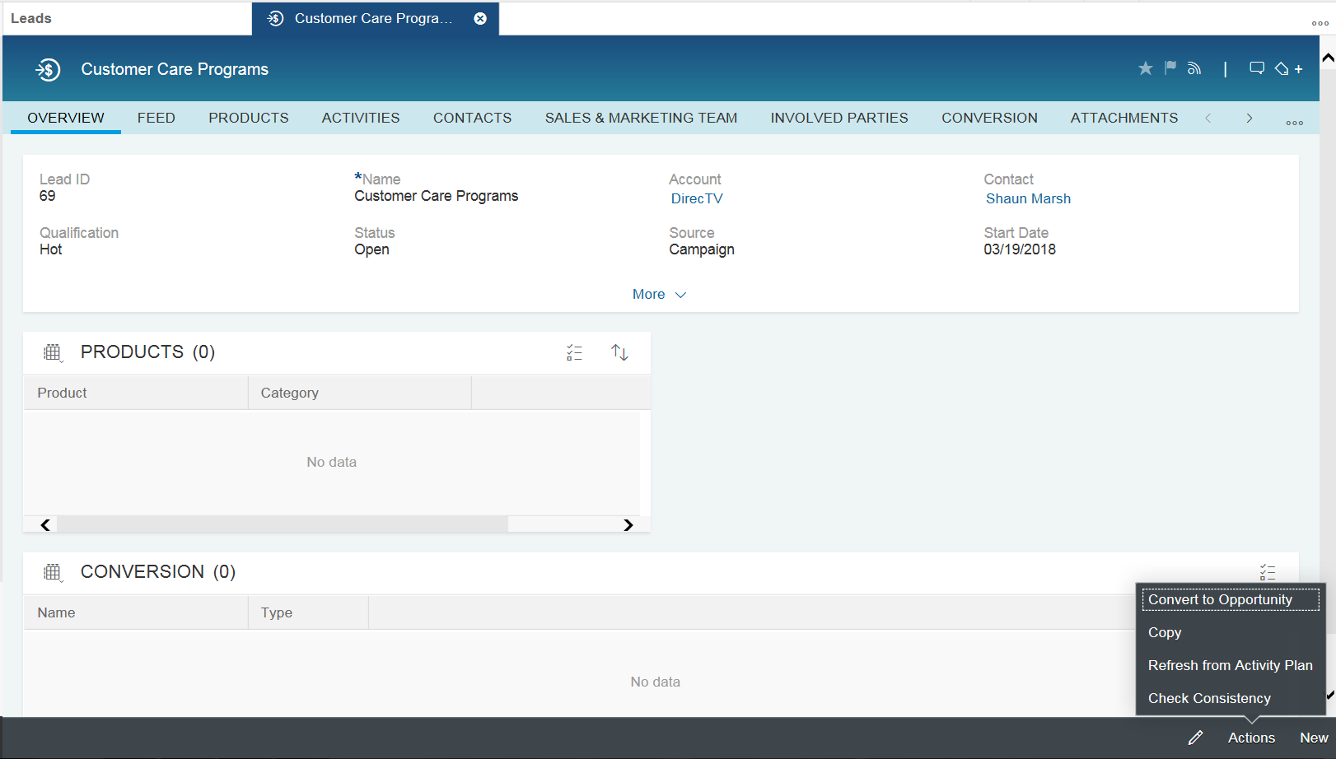
Figure 2.1.1.1.4 – ‘Convert to Opportunity’ action on the ‘Leads’ work center view
When a Lead is converted to an Opportunity, data elements that are common to both these transactions will be copied from the source transaction to the target transaction. The contents of custom fields will be copied to the target transaction (i.e.: Opportunity) through an enhancement. Refer to the FS: E-CIM-CS-16 – ‘Enhance the copy control logic for creating opportunities from leads’ for more details.
Search Capabilities: Users will be able to search for Leads individually or collectively using the following criteria:
Lead Type; Lead ID; Employee Responsible Name; Employee Responsible ID; Territory ID; Start Date; End Date; Customer BPID; Customer Name; Status; Campaign ID; Description; Contact Name; Contact ID; Created By; Contract Account ID; Utilities Contract ID, Party Role, and Partner ID.
The solution to search for leads based on attributes: Created By; Contract Account ID; Utilities Contract ID; Party Role, and Partner ID will be implemented through an enhancement. Refer to the FS: E-CIM-CS-16 – ‘Enhance the search criteria and results list for leads’ for more details.
See Section 2.8 for a complete list of fields that will be available for maintenance for a Lead transaction.
Mass Data Maintenance: Leads can also be updated in mass using the ‘Mass Data Maintenance’ feature in SAP Hybris C4C. The access to this feature will be restricted to super users (i.e.: Users assigned to Sales Professional – Super User and Territory Professional business roles).
Account Managers, DER Specialists, Account Coordinators, Analysts will be able to update the status of leads in mass using the ‘Update Lead Status’ action on the ‘Leads’ facet (Tab). The solution to update the status of leads in mass will be implemented through an enhancement. Refer to the FS: E-CM-CS-16 – ‘Enhancement to update the status of leads and opportunities in mass’ for more details.

      - Opportunity Management:
Opportunities can be created in SAP Hybris C4C on an individual basis as follow-up transactions of Leads, or from the ‘Opportunities’ facet (Tab) of an Account, Contact or Individual Customer record, or from the ‘Opportunities’ work center view.
Overview: The ‘General Data’ section on the ‘Overview’ facet (Tab) of the opportunity will contain the following fields:
Opportunity ID; Opportunity Description; Account; Primary Contact; Owner; Sales Organization; Distribution Channel; Division; Sales Unit; Campaign ID; Territory ID; Territory Name; Expected Value; Total Negotiated Value; Weighted Value; Probability; Publish to Forecast; Category; Source; Start Date; Close Date; Status; Reason for Status; Sales Cycle; Sales Phase and Days in Sales Phase.
The ‘Category’ field of the Opportunity will be used to categorize it as a ‘Customer Care’ opportunity.
The ‘Start Date’ of the Opportunity will be defaulted to the system date at the time of creation (i.e.: today’s date) and the ‘Close Date’ will be blank. However, the ‘Close Date’ will defined as a mandatory field and therefore must be entered to save the transaction.
The ‘Source’ field on the Opportunity header will be used to capture the origin. Note: For a complete list of values that will be available for selection for this field, see Section 2.8.
‘Utilities Contracts’ field will be added to the ‘Overview’ facet (Tab) of the Opportunity to support the assignment of a contract to an Opportunity. This solution will be implemented through an enhancement. Refer to the FS: E-CIM-CS-16 - ‘Enhance non-rebate program opportunities in SAP Hybris C4C with custom fields and business logic’ for more details.
Notes: Notes can be added to an Opportunity using the ‘Notes’ facet as shown in figure 2.1.1.2.1.
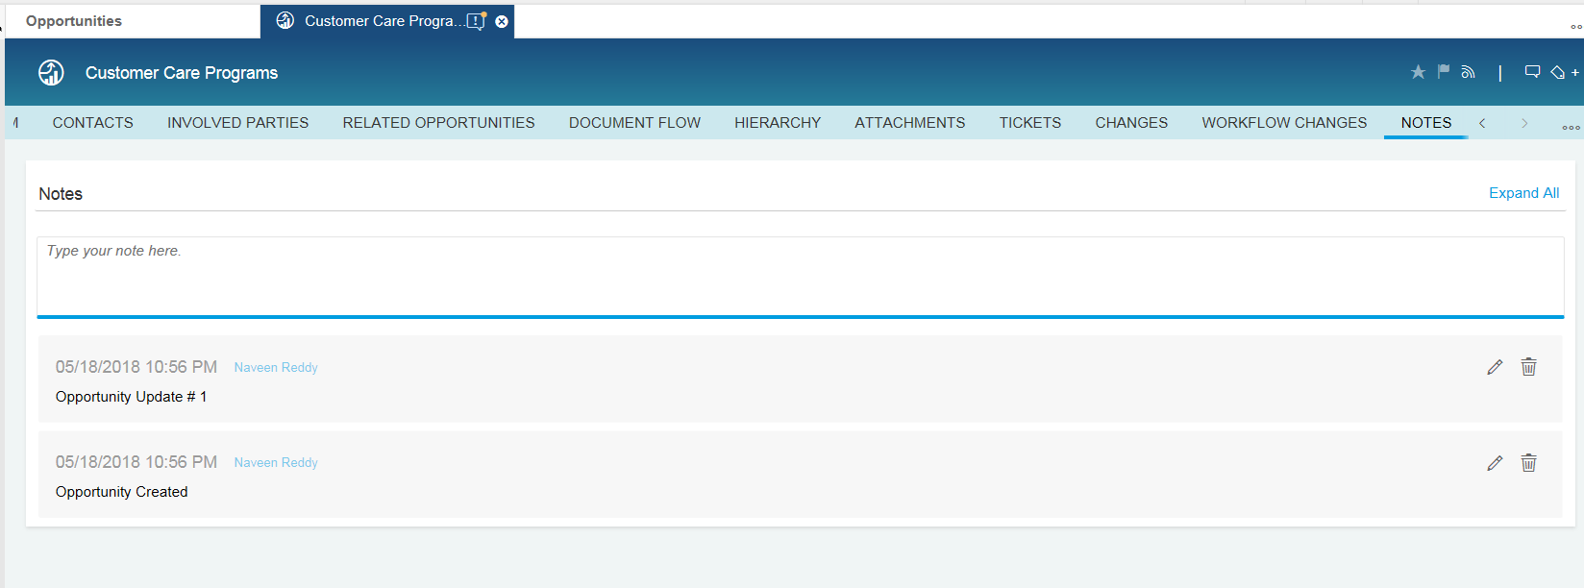
Figure 2.1.1.2.1 – ‘Notes’ facet on the ‘Opportunities’ work center view
Attachments: Attachments can be added to an Opportunity using the ‘Attachments’ facet (Tab) as shown in Figure 2.1.1.2.2.
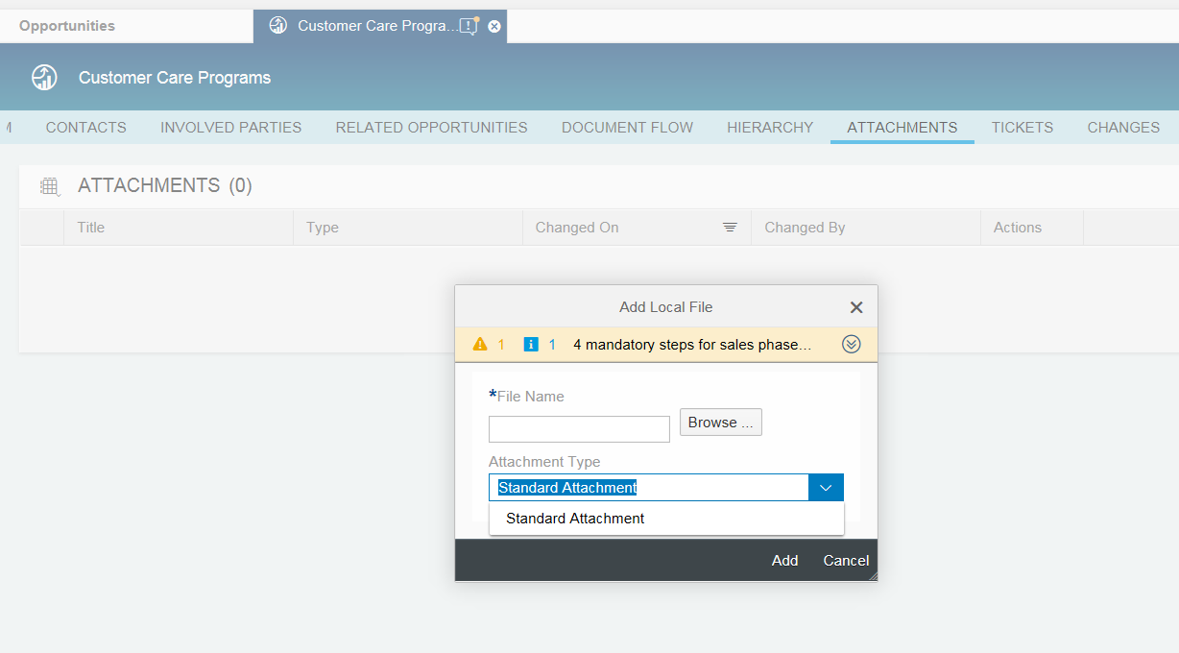
Figure 2.1.1.2.2 – ‘Attachments’ facet on the ‘Opportunities’ work center view
A Local File or a Web Link or a file from the Library can be added as an attachment. For Customer Care opportunities, ‘Standard Attachment’ will be defined as a Dropdown List value for the field: Attachment Type.
Change History: Change History for Opportunity attributes can be seen on the ‘Changes’ facet as shown in figure 2.1.1.2.3. The following attributes of an Opportunity transaction will be captured in the Change History:
Attachment External Address Link, Attachment File Name, Attachment Title, Category, Close Date, Contact Party Address, Contact Party ID, Contact Party Role, Currency Code, Custom Status, Distribution Channel, Entry Type, Expected Value, Item Description, Item Value, Main Party, Name, Party Address, Party ID, Party Role, Priority, Probability, Product Category ID, Product ID, Progress, Publish to Forecast, Quantity, Reason for Status, Reference Document ID, Reference Document Type, Sales Cycle, Sales Organization ID, Sales Phase, Source, Start Date, Status, Territory ID, Text, Total Negotiated Value, Unit of Measure and Weighted Value.

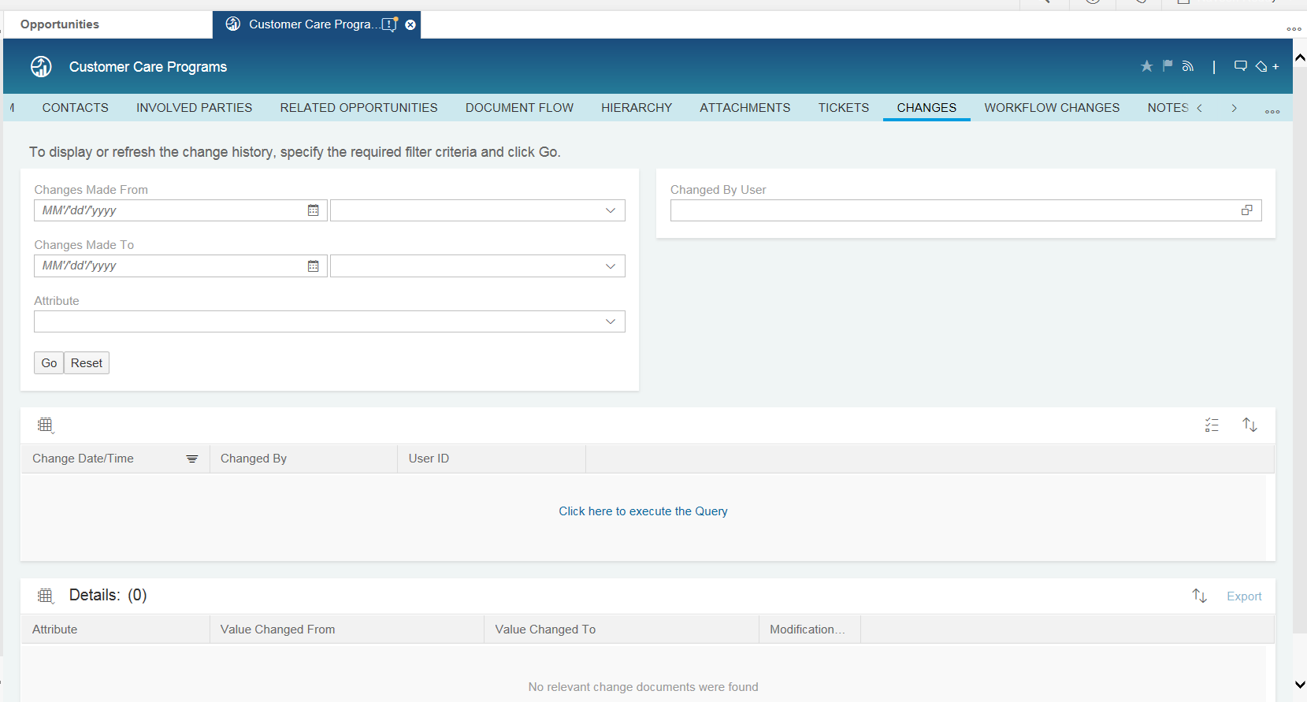
Figure 2.1.1.2.3 – ‘Changes’ facet on the ‘Opportunities’ work center view
Partner Determination: When an Opportunity is created as a follow-up transaction of a Lead or copied from another Opportunity, partners assigned to party roles that are common to both transactions will be copied over to the Opportunity transaction. If an Opportunity is created without reference to a Lead or another Opportunity, party roles: ‘Account Manger’, ‘Account Coordinator’, ‘DER Specialist’, ‘Inside Account Manager’ and ‘SCE Trade Pro Liaison’ will be automatically determined based on the Sales Territory ID determined for that transaction. Additionally, the following party roles will be available for manual maintenance in Opportunities:
- Auditor
- Economic Development Consultant
- Economic Development Analyst
- Engineer
- New Construction Representative
- Outreach Specialist
- SCE Analyst
- SCE Field Engineer
- SCE Pump Test Engineer
- Technical Coordinator
- Trade Professional
- Primary Facility Contact
- Design Team Member
- BCST Account Manager
- Agent

Search Capabilities: Users will be able to search for Opportunities by one or more of the following criteria:
Opportunity Type; Opportunity ID; Employee Responsible Name; Employee Responsible ID; Territory ID; Start Date; End Date; Customer BPID; Customer Name; Status; Campaign ID; Description; Contact Name; Contact ID; Created By; Contract Account ID; Utilities Contract ID; Party Role and Partner ID.
The solution to search for opportunities based on attributes: Created By; Contract Account ID; Utilities Contract ID; Party Role and Partner ID will be implemented through an enhancement. Refer to the FS: E-CIM-CS-16 – ‘Enhance the search criteria and results list for opportunities’ for more details.
See section 2.8 for a complete list of fields that will be available for maintenance for an Opportunity transaction.
Copy: While creating an opportunity as a copy of another opportunity, the contents of most of the standard fields will be copied to the target transaction. In order to copy the contents of custom fields, the copy logic will be enhanced. Refer to the FS: E-CIM-CS-16 - ‘Enhance the copy control logic to copy custom attributes from an opportunity to another opportunity’ for more details.
Mass Data Maintenance: Opportunities can also be updated in mass using the ‘Mass Data Maintenance’ feature in SAP Hybris C4C. The access to feature will be restricted to super users (i.e.: Users assigned to Sales Professional – Super User and Territory Professional business roles).
Account Managers, DER Specialists, Account Coordinators, Analysts will be able to update the status of leads in mass using the ‘Update Lead Status’ action on the ‘Leads’ facet (Tab). The solution to update the status of leads in mass will be implemented through an enhancement. Refer to the FS: E-CM-CS-16 – ‘Enhancement to update the status of leads and opportunities in mass’ for more details.

      - Activity Management:
Activities can be used to record information from interactions between business partners during the customer relationship lifecycle. These transactions can be linked to leads and opportunities, which in turn provide visibility to customer interactions that have taken place throughout the sales cycle. Activities can also be used to plan interactions with customers. In SAP Hybris C4C, activities include appointments, e-mails, phone calls and tasks.

Appointments: are planned activities that appear in calendars, including external appointments and scheduled meetings with business partners.
E-Mails: can be used to record interactions through the e-mail channel in SAP Hybris C4C.
Phone Calls: can be used to track and document phone calls with business partners in SAP Hybris C4C.
Tasks: can be used to record information about anything an employee needs to do by a certain date.

Appointments: can be created in SAP Hybris C4C on an individual basis from the ‘Activities’ facet of an Account, Contact or Individual Customer record, ‘Activities’ facet of a Lead or an Opportunity transaction or from the ‘Appointments’ work center view.
See Section 2.8 for a complete list of fields that will be available in SAP Hybris C4C for the creation and/ or maintenance for an Appointment.

E-Mails: can be created in SAP Hybris C4C on an individual basis from the ‘Activities’ facet of an Account, Contact or Individual Customer record or from the ‘Activities’ facet of a Lead or an Opportunity transaction.

E-Mails sent/ received from/ in Microsoft Outlook can be synchronized with SAP Hybris C4C. If these e-mails are linked to a specific account or lead or opportunity in MS Outlook, this association will also be synchronized with SAP Hybris C4C.
See section 2.8 for a complete list of fields that will be available in SAP Hybris C4C for the creation for an E-Mail.

Phone Calls: can be captured in SAP Hybris C4C on an individual basis from the ‘Activities’ facet of an Account, Contact or Individual Customer record, ‘Activities’ facet of a Lead or an Opportunity transaction or from the ‘Phone Calls’ work center view.
See Section 2.8 for a complete list of fields that will be available in SAP Hybris C4C for the creation and/ or maintenance for a Phone Call.

Tasks: can be created in SAP Hybris C4C on an individual basis from the ‘Activities’ facet of an Account, Contact or Individual Customer record, ‘Activities’ facet of a Lead or an Opportunity transaction or from the ‘Tasks’ work center view.
See Section 2.8 for a complete list of fields that will be available in SAP Hybris C4C for the creation and/ or maintenance for a Task.

Sales personnel in the BCD (i.e.: Account Managers, Account Coordinators, Economic Development Consultants, etc.) may reach out to various COE’s (Center of Expertise) within SCE for assistance with sales or service activities by creating a Service Ticket. The following is a list of COE’s that support the BCD:
COE – BCD CRM
COE – Campaign
COE – Customer Care
COE – Customer Generation
COE – Data Solutions
COE – Distributed Energy Resources (DER)
COE – Economic Development
COE - Outage
COE – Pump Test
COE – Rate Analysis
COE – Transportation Electrification (formerly, COE – PEV)

Service Tickets: can be created in SAP Hybris C4C on an individual basis from the ‘Tickets’ facet of an Organization BP, Contact or Person BP , ‘Tickets’ facet of a Lead or an Opportunity transaction or from the ‘Tickets’ work center view.
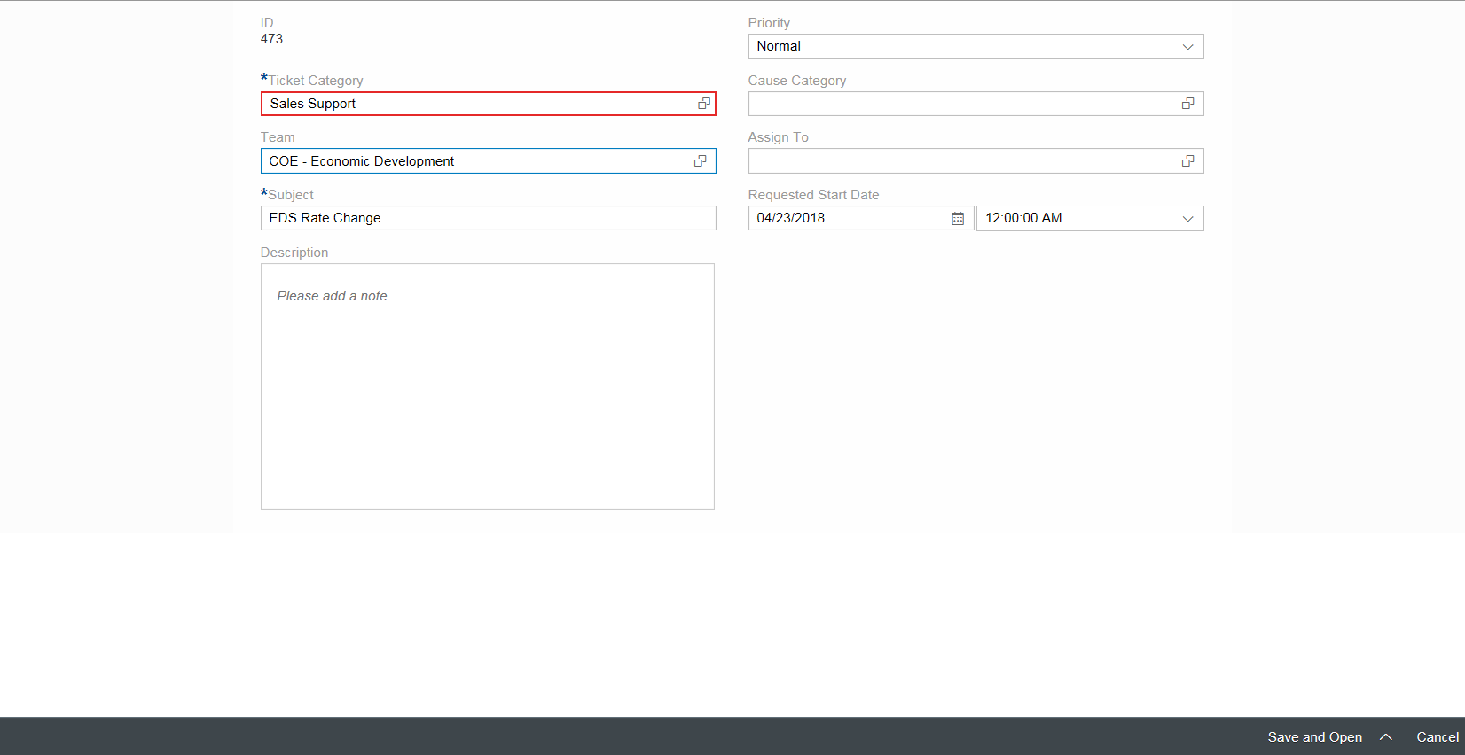
Figure 2.1.1.3.1 – ‘Service Ticket Create’ screen
Depending on the nature of the request, it will be assigned to one of the COE’s. Upon creation, it will appear in the queue of the assigned service team.
See Section 2.8 for a complete list of fields that will be available in SAP Hybris C4C for the creation and/ or maintenance for a ‘Sales Support’ Service Ticket.
Refer to the BPD: CIM-CS-17 – Front Office for details on Feeds, Tags and Shelf capabilities in SAP Hybris C4C.

    - Economic Development Sales Cycle:
A Business Partner’s intent to participate in (or) SCE’s intent to consider BP’s for Economic Development projects within SCE’s service territory will be recorded in SAP Hybris C4C as leads. Account Managers create Economic Development Leads on an individual basis.
Incoming leads will be assigned to the ‘Economic Development Services’ organization for qualification and further processing. Refer to Section 2.1.1.1 for the lead distribution rules.
Leads assigned to Economic Development Services personnel will be processed repeatedly to establish and improve the level of interest represented by the lead and transform the lead to an opportunity. In each process iteration, the lead status and qualification level are updated as needed. Interactions with prospects or customers throughout the lead qualification process can be recorded using various types of activities. Refer to Section 2.1.1.3 for details on Activity Management.
Qualified leads can be converted to opportunities. An Economic Development Lead will be converted to an Economic Development Opportunity using the ‘Convert to Opportunity’ action on the lead transaction. All relevant information will be copied to the target transaction. When a lead is converted to an opportunity, it remains in the system as a record. Converted leads cannot be changed or deleted, but follow-up items that arise from the lead can be processed as needed. Alternatively, the sales cycle of an Economic Development project may also begin with an Opportunity (i.e.: without a preceding Lead).
An Economic Development Opportunity goes through a sales cycle that is characterized by different stages. Specific activities are carried out in these stages. Activity Advisor will be used to suggest the activities to be carried out in each stage, where each stage represents a stage for processing an Economic Development Rate (EDR) application. Interactions with prospects or customers throughout the sales cycle can be recorded using various types of activities. Refer to Section 2.1.1.3 for details on Activity Management. An Economic Development project ends in SAP Hybris C4C with the Opportunity transaction, upon which its status will be set to ‘Won’ or ‘Lost’. When the status of the opportunity is set to ‘Won’, Economic Development Consultants or Economic Development Analysts may create a Service Ticket/BPEM to request the Revenue Services Organization at SCE to change the rate on the Utilities Contract (i.e.: to request an EDR rate change). Refer to Section 2.1.1.3 for details on the solution to create service tickets to request assistance from other departments at SCE.

      - Lead Management:
The Lead Management solution for Economic Development will be same as that of Customer Care with the following exceptions:
- Economic Development leads will not be created via the Campaign Management solution.
- The ‘Category’ field on a lead transaction will be used to categorize ‘Economic Development’ leads as: ‘Economic Development Attraction’, ‘Economic Development Retention’, ‘Economic Development Expansion’, ‘Economic Development Retention-Expansion’ and ‘Economic Development Retention-Attraction.
- Economic Development leads will be assigned to the ‘Economic Development Services’ sales organization.
- ‘Employee Responsible’ partner function will be left blank even through the Territory ID is determined for an Economic Development Services Lead. This will be implemented through an enhancement. Refer to the FS: E-CIM-CS-16 - ‘Enhance leads in SAP Hybris C4C with custom fields and business logic’ for more details.

Refer to section 2.1.1.1 for details.

      - Opportunity Management:
Opportunities can be created in SAP Hybris C4C on an individual basis as follow-up transactions of Leads, or from the ‘Opportunities’ facet of an Organization BP, Contact, or Person BP record, or from the ‘Opportunities’ work center view.
Overview: The ‘General Data’ section on the ‘Overview’ facet of the ‘Economic Development Services’ opportunity will contain the following fields:
Opportunity ID; Opportunity Description; Account; Primary Contact; Owner; Sales Organization; Distribution Channel; Division; Sales Unit; Campaign ID; Territory ID; Territory Name; Expected Value; Total Negotiated Value; Weighted Value; Probability; Publish to Forecast; Category; Source; Start Date; Close Date; Status; Reason for Status; Sales Cycle; Sales Phase; Days in Sales Phase; NAICS Code; Proposed City Move/ Expand To; Proposed State Move/ Expand To; Proposed Country Move/ Expand To; EDR Discussion Date; EDR Candidate; Projected Annual Revenues; Total Investments and EDR Status.
The ‘Category’ field on an Opportunity transaction will be used to categorize ‘Economic Development’ opportunities as: ‘Economic Development Services Attraction’, ‘Economic Development Services Retention’, ‘Economic Development Services Expansion’, ‘Economic Development Services Retention-Expansion’ and ‘Economic Development Services Retention-Attraction. If an Opportunity is created as a follow-up transaction of a Lead, then the ‘Category’ field value will be copied to the target transaction.
The ‘Start Date’ of the Opportunity will be defaulted to the system date at the time of creation (i.e.: today’s date), but may be modified to a past date. The ‘Close Date’ will be blank. Note: ‘Close Date’ will defined as an optional field for Opportunity Type – ‘Economic Development Services’. Upon setting the status of the opportunity to ‘Won’ or ‘Lost’, the ‘Close Date’ will be set to the current date/ system date.
The ‘Source’ field on the Opportunity header will be used to capture the origin. Note: For a complete list of values that will be available for selection for this field, see section 2.8.
The ‘NAICS Code’ field will be added to the ‘Overview’ facet of the Economic Development Services Opportunity and its value will be derived from the Business Partner assigned to the ‘Account’ field of the transaction. This will be implemented through an enhancement. Refer to the FS: E-CIM-CS-16 - ‘Enhance non-rebate program opportunities in SAP Hybris C4C with custom fields and business logic’ for more details.
Proposed City Move/ Expand To; Proposed State Move/ Expand To; Proposed Country Move/ Expand To; EDR Candidate; Projected Annual Revenues and Total Investments will be added as custom fields of type ‘Text’. EDR Discussion Date will be added as a custom field of type ‘Date’.
‘Utilities Contracts’ section will be added on the ‘Overview’ facet of the Opportunity to support the assignment of multiple contracts to an Opportunity. See figure 2.1.2.2.1. This solution will be implemented through an enhancement. Refer to the FS: E-CIM-CS-16 - ‘Enhance non-rebate program opportunities in SAP Hybris C4C with custom fields and business logic’ for more details.
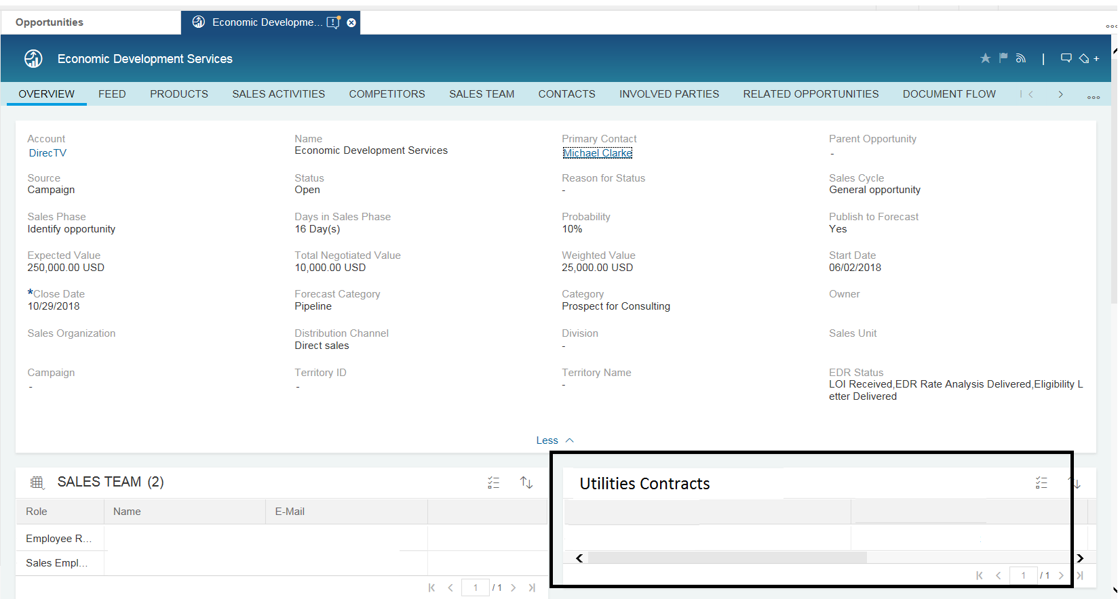
Figure 2.1.2.2.1 – ‘Utilities Contracts’ section on the ‘Overview facet
‘Topics Covered’ section will be added on the ‘Overview’ facet as shown in Figure 2.1.2.2.2. This solution will be implemented through an enhancement. Refer to the FS: E-CIM-CS-16 - ‘Enhance non-rebate program opportunities in SAP Hybris C4C with custom fields and business logic’ for more details.
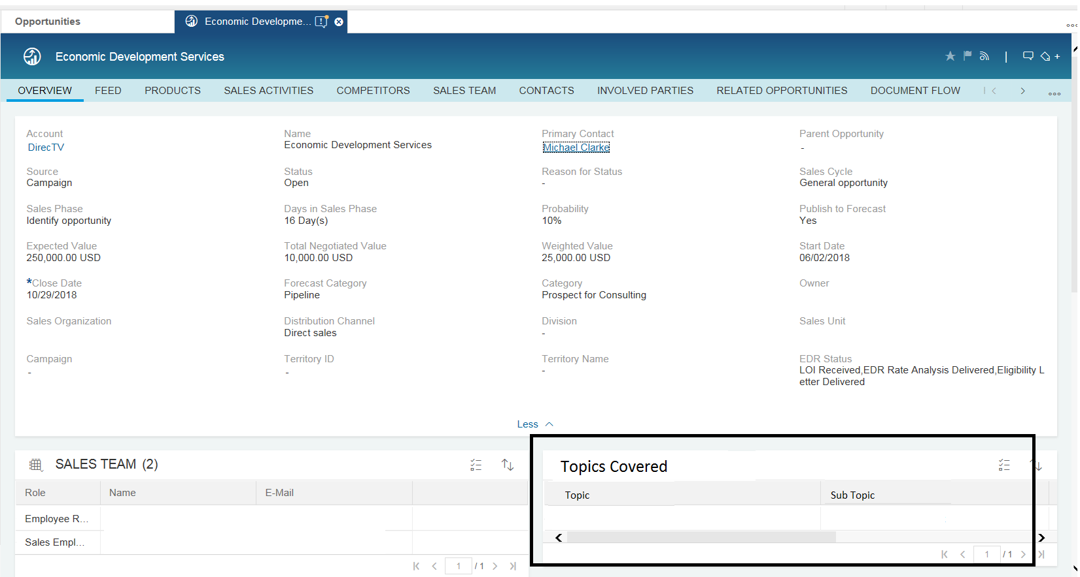
Figure 2.1.2.2.2 – ‘Topics Covered’ section on the ‘Overview facet
Note: For a complete list of values that will be available for selection for ‘Topic’ and ‘Sub Topic’ fields, see Section 2.8.

‘Additional Details’ section will be added on the ‘Overview’ facet as shown in Figure 2.1.2.2.4. This solution will be implemented through an enhancement. Refer to the FS: E-CIM-CS-16 - ‘Enhance non-rebate program opportunities in SAP Hybris C4C with custom fields and business logic’ for more details.
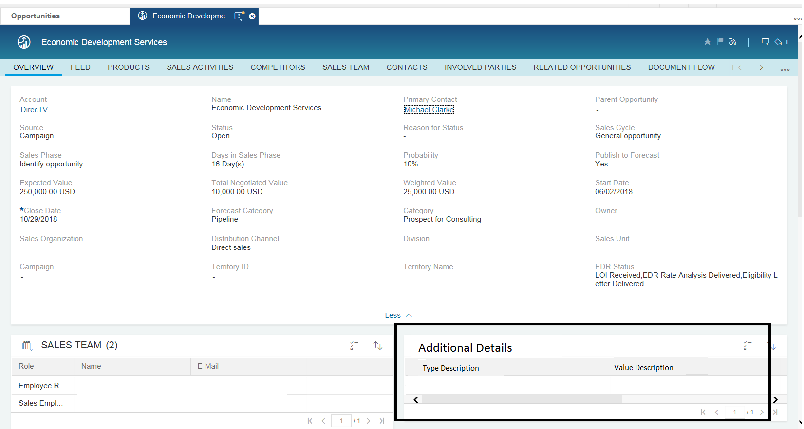
Figure 2.1.2.2.4 – ‘Additional Details’ section on the ‘Overview facet
Note: For a complete list of values that will be available for selection for ‘Type Description’ and ‘Value Description’ fields, see section 2.8.
Sales Activities: Sales Cycle – ‘Economic Development Services’ will be defined with a Sales Phase – ‘EDR Process’. The following activities will be assigned to this sales phase:
- LOI Received
- EDR Rate Analysis Delivered
- Eligibility Letter Delivered
- Latest Business Case Received
- Economic Development Services Approved
- Economic Development Services Denied
- State Economic Development Approved
- State Economic Development Denied
- Regulatory Approved
- Regulatory Denied
- Legal Approved
- Legal Denied
- EDR Affidavit Signed
- EDR Contract Signed
- EDR Applied
- EDR Completed
- EDR Declined
- EDR On Hold
- EDR Withdrawn

These activities will be available for selection in the ‘Activity Advisor’ section on the ‘Sales Activities’ facet.
Additionally, a new field ‘EDR Status’ will be added to the Opportunity Type – ‘Economic Development Services’.
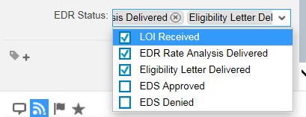

Notes: Notes can be added to an Opportunity using the ‘Notes’ facet as shown in Figure 2.1.1.2.1. Note: It is not possible to select a note type in an Opportunity in SAP Hybris C4C.
Attachments: Attachments can be added to an Opportunity using the ‘Attachments’ facet as shown in Figure 2.1.1.2.2. A Local File or a Web Link or a file from the Library can be added as an attachment. For Economic Development opportunities, ‘Standard Attachment’ will be defined as a Dropdown List Value for the field: Attachment Type.
Change History: Change History for Opportunity attributes can be seen on the ‘Changes’ facet as shown in Figure 2.1.1.2.3. The following attributes of an Opportunity transaction will be captured in the Change History:
Attachment External Address Link, Attachment File Name, Attachment Title, Category, Close Date, Contact Party Address, Contact Party ID, Contact Party Role, Currency Code, Custom Status, Distribution Channel, Entry Type, Expected Value, Item Description, Item Value, Main Party, Name, Party Address, Party ID, Party Role, Priority, Probability, Product Category ID, Product ID, Progress, Publish to Forecast, Quantity, Reason for Status, Reference Document ID, Reference Document Type, Sales Cycle, Sales Organization ID, Sales Phase, Source, Start Date, Status, Territory ID, Text, Total Negotiated Value, Unit of Measure and Weighted Value.
Partner Determination: When an Opportunity is created as a follow-up transaction of a Lead or copied from another Opportunity, partners assigned to party roles that are common to both transactions will be copied over to the Opportunity transaction. If an Opportunity is created without reference to a Lead or another Opportunity, party roles: ‘Account Manger’, ‘Account Coordinator’, ‘Inside Account Manager’ and ‘DER Specialist’ will be automatically determined based on the Sales Territory ID determined for that transaction. Additionally, the following party roles will be available for manual maintenance in Opportunities:
- Economic Development Services Consultant
- Economic Development Services Analyst
- Engineer
- New Construction Representative
- Outreach Specialist
- SCE Analyst
- SCE Field Engineer
- SCE Pump Test Engineer
- SCE Trade Pro Liaison
- Auditor
- BCST Account Manager
- Agent
Search Capabilities: Users will be able to search for Opportunities by one or more of the following criteria:
Opportunity Type; Opportunity ID; Employee Responsible Name; Employee Responsible ID; Territory ID; Start Date; End Date; Customer BPID; Customer Name; Status; Campaign ID; Description; Contact Name; Contact ID; Created By; Contract Account ID; Utilities Contract ID; Party Role and Partner ID.
The solution to search for opportunities based on attributes: Created By; Contract Account ID; Utilities Contract ID; Party Role and Partner ID will be implemented through an enhancement. Refer to the FS: E-CIM-CS-16 – ‘Enhance the search criteria and results list for opportunities’ for more details.
See Section 2.8 for a complete list of fields that will be available for maintenance for an Opportunity transaction.
Copy: While creating an opportunity as a copy of another opportunity, the contents of most of the standard fields will be copied to the target transaction. In order to copy the contents of custom fields, the copy logic will be enhanced. Refer to the FS: E-CIM-CS-16: ‘Enhance the copy control logic to copy custom attributes from an opportunity to another opportunity’ for more details.
Mass Data Maintenance: Opportunities can also be updated in mass using the ‘Mass Data Maintenance’ feature in SAP Hybris C4C. The access to feature will be restricted to super users (i.e.: Users assigned to Sales Professional – Super User and Territory Professional business roles).
Account Managers, DER Specialists, Account Coordinators, Analysts will be able to update the status of leads in mass using the ‘Update Lead Status’ action on the ‘Leads’ facet (Tab). The solution to update the status of leads in mass will be implemented through an enhancement. Refer to the FS: E-CM-CS-16 – ‘Enhancement to update the status of leads and opportunities in mass’ for more details.

      - Activity Management:
The Activity Management solution for Economic Development will be same as that of Customer Care. Refer to Section 2.1.1.3 for details.

    - New Construction Sales Cycle:
A Business Partner’s intent to participate in (or) SCE’s intent to consider BP’s for New Construction projects within SCE’s service territory will be recorded in SAP Hybris C4C as leads. Account Managers create New Construction Leads on an individual basis or in bulk.
‘New Construction’ Leads and Opportunities may be created in SAP Hybris C4C for Prospects or Customers. When a Prospect decides to move forward with the ‘New Construction’ project, an Account Manger may submit a service ticket to ‘COE – Customer Care’ Account Coordinator or Analyst to convert the Prospect to a Customer. Refer to the BPD: CIM-CS-01 – ‘Business Master Data – Manage Business Partner’ for details on the conversion of a Prospect to Customer. Upon conversion, an application can be created in iEnergy.
Incoming leads will be assigned to the ‘New Construction’ sales organization for qualification and further processing. Refer to Section 2.1.1.1 for the lead distribution rules.
Leads assigned to sales personnel will be processed repeatedly to establish and improve the level of interest represented by the lead and transform the lead to an opportunity. In each process iteration, the lead status and qualification level are updated as needed. Interactions with prospects or customers throughout the lead qualification process can be recorded using various types of activities. Refer to Section 2.1.1.3 for details on Activity Management.
Qualified leads can be converted to opportunities. A New Construction Lead will be converted to a New Construction Opportunity using the ‘Convert to Opportunity’ action on the lead transaction. All relevant information will be copied to the target transaction. When a lead is converted to an opportunity, it remains in the system as a record. Converted leads cannot be changed or deleted, but follow-up items that arise from the lead can be processed as needed. Alternatively, the sales cycle of a New Construction project may also begin with an Opportunity (i.e.: without a preceding Lead).
A New Construction Opportunity goes through a sales cycle that is characterized by different stages. Specific sales activities are carried out in these stages. Interactions with prospects or customers throughout the sales cycle can be recorded using various types of activities. Refer to section 2.1.1.3 for details on Activity Management. A New Construction project ends in SAP Hybris C4C with the Opportunity transaction, upon which its status will be set to ‘Won’ or ‘Lost’. When the status of the opportunity is set to ‘Won’, Account Managers create an application in iEnergy to capture customer’s intent to move forward with the project.

      - Lead Management:
The Lead Management solution for New Construction will be same as that of Customer Care. Refer to Section 2.1.1.1 for details.

      - Opportunity Management:
Opportunities can be created in SAP Hybris C4C on an individual basis as follow-up transactions of Leads, or from the ‘Opportunities’ facet of an Account, Contact or Individual Customer record, or from the ‘Opportunities’ work center view.
Overview: The ‘General Data’ section on the ‘Overview’ facet of the ‘New Construction’ opportunity will contain the following fields:
Opportunity ID; Opportunity Description; Account; Primary Contact; Owner; Sales Organization; Distribution Channel; Division; Sales Unit; Campaign ID; Territory ID; Territory Name; Expected Value; Total Negotiated Value; Weighted Value; Probability; Publish to Forecast; Category; Source; Start Date; Close Date; Status; Reason for Status; Sales Cycle; Sales Phase; Days in Sales Phase; Projected Revenue; Influence; Market Identifier; Program ID and Program Description.
The ‘Category’ field on an Opportunity transaction will be used to categorize it as a ‘New Construction’ opportunity.
The ‘Source’ field on the Opportunity transaction will be used to capture the origin. Note: For a complete list of values that will be available for selection for this field, see section 2.8.
The ‘Start Date’ of the Opportunity transaction will be defaulted to the system date at the time of creation (i.e.: today’s date), but may be modified to a past date. The ‘Close Date’ will be blank. Note: ‘Close Date’ will defined as an optional field for Opportunity Type – ‘New Construction’.
The ‘Status’ field on the Opportunity transaction will be used to capture the status of the opportunity.
The ‘Sales Phase’ field on the Opportunity transaction will be used to capture the current stage of the opportunity. The following values will be available for selection for this field: Initial Stage; Develop Proposal; Closing Conversation/ Commitment.
Utilities Contract ID; Projected Revenue; Program ID and Program Description will be added to the ‘General Data’ section through an enhancement. Refer to the FS: E-CIM-CS-16 - ‘Enhance rebate program and new construction opportunities in SAP Hybris C4C with custom fields and business logic’ for more details.
Influence and Market Identifier will be added to the ‘General Data’ section as custom fields of type ‘List’ (i.e.: A Field with a Dropdown list).
‘Energy Savings Totals’ section will be added on the ‘Overview’ facet as shown in Figure 2.1.3.2.1. ‘Base Value’ will be the sum of the ‘Baseline Value’ for KW or KWH or THERMS of each line item. ‘Inst Value’ will be the sum of the ‘Installed Value’ for KW or KWH or THERMS of each line item. ‘Gross Savings’ will be the sum of the ‘Energy Savings’ for KW or KWH or THERMS of each line item. This solution will be implemented through an enhancement. Refer to the FS: E-CIM-CS-16 - ‘Enhance rebate program and new construction opportunities in SAP Hybris C4C with custom fields and business logic’ for more details.

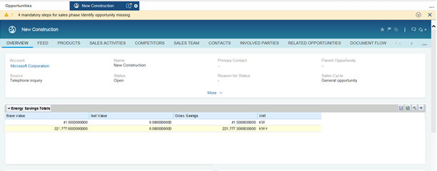
Figure 2.1.3.2.1 – ‘Energy Savings Totals’ section on the ‘Overview facet
Notes: Notes can be added to an Opportunity using the ‘Notes’ facet as shown in Figure 2.1.1.2.1. Note: It is not possible to select a note type in an Opportunity in SAP Hybris C4C.
Attachments: Attachments can be added to an Opportunity using the ‘Attachments’ facet as shown in Figure 2.1.1.2.2. A Local File or a Web Link or a file from the Library can be added as an attachment. For New Construction opportunities, ‘Standard Attachment’ will be defined as a Dropdown List Value for the field: Attachment Type.
Change History: Change History for Opportunity attributes can be seen on the ‘Changes’ facet as shown in Figure 2.1.1.2.3. The following attributes of an Opportunity transaction will be captured in the Change History:
Attachment External Address Link, Attachment File Name, Attachment Title, Category, Close Date, Contact Party Address, Contact Party ID, Contact Party Role, Currency Code, Custom Status, Distribution Channel, Entry Type, Expected Value, Item Description, Item Value, Main Party, Name, Party Address, Party ID, Party Role, Priority, Probability, Product Category ID, Product ID, Progress, Publish to Forecast, Quantity, Reason for Status, Reference Document ID, Reference Document Type, Sales Cycle, Sales Organization ID, Sales Phase, Source, Start Date, Status, Territory ID, Text, Total Negotiated Value, Unit of Measure and Weighted Value.
Partner Determination: When an Opportunity is created as a follow-up transaction of a Lead or copied from another Opportunity, partners assigned to party roles that are common to both transactions will be copied over to the Opportunity transaction. If an Opportunity is created without reference to a Lead or another Opportunity, party roles: ‘Account Manger’, ‘Account Coordinator’, ‘Inside Account Manager’ and ‘DER Specialist’ will be automatically determined based on the Sales Territory ID determined for that transaction. Additionally, the following party roles will be available for manual maintenance in Opportunities:
- Economic Development Services Consultant
- Economic Development Services Analyst
- Customer Solutions Representative
- Engineer
- New Construction Representative
- Outreach Specialist
- SCE Analyst
- SCE Field Engineer
- SCE Pump Test Engineer
- SCE Trade Pro Liaison
- Auditor
- Agent
Items: can be added to an Opportunity transaction on the ‘Products’ facet. Each item of a New Construction Opportunity represents a measure. The ‘New Construction Item’ will include the following fields: Product ID, Product Description, Category ID, Category Description, Unit of Measure, Quantity, Notes, Baseline Value, Installed Value, Energy Savings (KWH), Energy Savings (KW) and Energy Savings (THERMS). The solution to include custom fields on the ‘Products’ facet of an Opportunity transaction will be implemented through an enhancement. Refer to the FS: E-CIM-CS-16 - ‘Enhance rebate program and new construction opportunities in SAP Hybris C4C with custom fields and business logic’ for more details.
Note: CP&S will be responsible for creating and maintaining products for rebate programs and BCD Operations -> Customer Care will be responsible for all non-rebate program products.
Estimated Savings Calculation: ‘Baseline Value’ and ‘Installed Value’ will be entered manually at the line item level. ‘Energy Savings’ will be calculated using the formula: Energy Savings (KWH/ KW/ THERMS) = Baseline Value – Installed Value. The solution to calculate Energy Savings will be implemented through an enhancement. Refer to the FS: E-CIM-CS-16 – ‘Enhancement to calculate Energy Savings in an Opportunity’ for more details.
iEnergy Integration: A New Construction project ends in SAP Hybris C4C with the Opportunity transaction, upon which its status will be set to ‘Won’ or ‘Lost’. When the status of the opportunity is set to ‘Won’, Account Managers will be able to create an application in iEnergy using the action ‘Create Application’. The solution to facilitate the creation of an application in iEnergy from an opportunity in SAP Hybris C4C will be implemented through an interface. Refer to the FS: E-CIM-CS-16 – ‘Enhancement to trigger the web service to create an application in iEnergy from an opportunity in SAP Hybris C4C’ for more details. When an application is created in iEnergy from an opportunity in SAP Hybris C4C, the following attributes will be copied to the target transaction:
Header: Transaction Description, Account ID, Contact ID, Utilities Contract ID, Publish to Forecast, Owner, Sales Territory ID, Building Type, NAICS Code, Industry Description, Climate Zone, Meter Number, Square Feet, Conditioned Square Feet, Percent Better than T-24, Year Built and Calculation Tool.
Items: Item Number, Product ID, Product Description, Product Category, List Price, Quantity, Unit of Measure, Proposed Value, Negotiated Value, Notes, Baseline Value and Installed Value.
Sales Team: Role, Name, E-Mail and Phone.
Contacts: Name, Phone, Mobile, E-Mail and Primary Contact.
Parties Involved: Role, Name, E-Mail, Phone, Primary and Primary Contact.
Attachments: File Name and Attachment Type.
Search Capabilities: Users will be able to search for Opportunities by one or more of the following criteria:
Opportunity Type; Opportunity ID; Employee Responsible Name; Employee Responsible ID; Territory ID; Start Date; End Date; Customer BPID; Customer Name; Status; Campaign ID; Description; Contact Name; Contact ID; Created By; Contract Account ID; Utilities Contract ID; Party Role and Partner ID.
The solution to search for opportunities based on attributes: Created By; Contract Account ID; Utilities Contract ID; Party Role and Partner ID will be implemented through an enhancement. Refer to the FS: E-CIM-CS-16 – ‘Enhance the search criteria and results list for opportunities’ for more details.
See Section 2.8 for a complete list of fields that will be available for maintenance for an Opportunity transaction.
Copy: While creating an opportunity as a copy of another opportunity, the contents of most of the standard fields will be copied to the target transaction. In order to copy the contents of custom fields, the copy logic will be enhanced. Refer to the FS: E-CIM-CS-16: ‘Enhance the copy control logic to copy custom attributes from an opportunity to another opportunity’ for more details.
Mass Data Maintenance: Opportunities can also be updated in mass using the ‘Mass Data Maintenance’ feature in SAP Hybris C4C. The access to feature will be restricted to super users (i.e.: Users assigned to Sales Professional – Super User and Territory Professional business roles).
Account Managers, DER Specialists, Account Coordinators, Analysts will be able to update the status of leads in mass using the ‘Update Lead Status’ action on the ‘Leads’ facet (Tab). The solution to update the status of leads in mass will be implemented through an enhancement. Refer to the FS: E-CM-CS-16 – ‘Enhancement to update the status of leads and opportunities in mass’ for more details.

      - Activity Management:
The Activity Management solution for New Construction will be same as that of Customer Care. Refer to Section 2.1.1.3 for details.

    - Rebate Program Sales Cycle:
A Business Partner’s intent to participate in (or) SCE’s intent to consider BP’s for Rebate Program initiatives will be recorded in SAP Hybris C4C as leads. Account Managers, Inside Account Managers, and DER Specialists, create Rebate Program Leads on an individual basis as a follow up to a customer interaction. These types of leads can also be created in SAP Hybris C4C as a result of campaign execution in SAP Hybris Marketing. Refer to the BPD: CIM-CS-15 - ‘Manage Customer Segmentation and Campaigns’ for details on the creation of leads from campaigns in SAP Hybris Marketing and transferring them to SAP Hybris C4C.
Incoming leads will be assigned to appropriate sales personnel based on pre-defined business rules for qualification and further processing. Refer to section 2.1.1.1 for the lead distribution rules.
Leads assigned to sales personnel will be updated repeatedly to establish and improve the level of interest represented by the lead and transform the lead to an opportunity. In each process iteration, the lead status and qualification level are updated as needed. Interactions with prospects or customers throughout the lead qualification process can be recorded using various types of activities. Refer to section 2.1.1.3 for details on Activity Management.
Qualified leads can be converted to opportunities. A Rebate Program Lead will be converted to a Rebate Program Opportunity using the ‘Convert to Opportunity’ action on the lead transaction. All relevant information will be copied to the target transaction. When a lead is converted to an opportunity, it remains in the system as a record. Converted leads cannot be changed or deleted, but follow-up items that arise from the lead can be processed as needed.
If an energy audit is needed to calculate savings for a project, an Account Manager or Inside Account Manager (IAM) will manually create a Work Ticket in SAP Hybris C4C as a follow-up transaction of a Rebate Program Lead which has been set to ‘Accepted’ status. Upon completion of the energy audit, the IAM will create a Rebate Program Opportunity as a follow-up transaction of a Work Ticket in SAP Hybris C4C and savings will be copied to the Rebate Program Opportunity transaction. Alternatively, a Rebate Program Opportunity can be created without a preceding Rebate Program Lead if savings are identified during the customer interaction.
A Rebate Program Opportunity goes through a sales cycle that is characterized by different stages. Specific sales activities are carried out in these stages. Interactions with prospects or customers throughout the sales cycle can be recorded using various types of activities. Refer to section 2.1.1.3 for details on Activity Management. If the customer decides to proceed with the project, the IAM will set the status of the Rebate Program Opportunity to ‘Won’ and trigger the process to create an application in iEnergy. If not, the IAM will set the status of the Opportunity to ‘Lost’, which marks the end of the Rebate Program sales cycle.

      - Lead Management:
The Lead Management solution for Rebate Programs will be same as that of Customer Care with the following exceptions:
- The ‘Category’ field on a lead transaction will be used to categorize these leads as: ‘Rebate Program’ lead.

Refer to Section 2.1.1.1 for details.
If an energy audit is needed to calculate savings for a project, an Account Manager or Inside Account Manager (IAM) will manually create a Work Ticket in SAP Hybris C4C as a follow-up transaction of a Rebate Program Lead which has been set to ‘Accepted’ status. Note: User should be able to create a Work Ticket as a follow-up transaction of a Lead only when the status of the lead is ‘Accepted’. Refer to Section 2.1.4.3 for details on the solution to facilitate energy audits.
Upon completion of the energy audit, the IAM will create a Rebate Program Opportunity as a follow-up transaction of a Work Ticket in SAP Hybris C4C and savings will be copied to the Rebate Program Opportunity transaction. Alternatively, a Rebate Program Opportunity can be created without a preceding Rebate Program Lead if savings are identified during the customer interaction.

      - Opportunity Management:
Opportunities can be created in SAP Hybris C4C on an individual basis as follow-up transactions of Leads, or from the ‘Opportunities’ facet of an Account, Contact or Individual Customer record, or from the ‘Opportunities’ work center view.
Overview: The ‘General Data’ section on the ‘Overview’ facet of the ‘Rebate Program’ opportunity will contain the following fields:
Opportunity ID; Opportunity Description; Account; Primary Contact; Owner; Sales Organization; Distribution Channel; Division; Sales Unit; Campaign ID; Territory ID; Territory Name; Expected Value; Total Negotiated Value; Weighted Value; Probability; Publish to Forecast; Category; Source; Start Date; Close Date; Status; Reason for Status; Sales Cycle; Sales Phase; Days in Sales Phase; Utilities Contract ID; Projected Revenue; Influence; Market Identifier; Program ID and Program Description.
The ‘Category’ field on an Opportunity transaction will be used to categorize it as a ‘Rebate Program’ opportunity.
The ‘Source’ field on the Opportunity transaction will be used to capture the origin. Note: For a complete list of values that will be available for selection for this field, see Section 2.8.
The ‘Start Date’ of the Opportunity transaction will be defaulted to the system date at the time of creation (i.e.: today’s date), but may be modified to a past date. The ‘Close Date’ will be blank. Note: ‘Close Date’ will defined as an optional field for Opportunity Type – ‘Rebate Program’.
The ‘Status’ field on the Opportunity transaction will be used to capture the status of the opportunity.
The ‘Sales Phase’ field on the Opportunity transaction will be used to capture the current stage of the opportunity. The following values will be available for selection for this field: Initial Stage; Develop Proposal; Closing Conversation/ Commitment.
Utilities Contract ID; Projected Revenue; Program ID and Program Description will be added to the ‘General Data’ section through an enhancement. Refer to the FS: E-CIM-CS-16 - ‘Enhance rebate program and new construction opportunities in SAP Hybris C4C with custom fields and business logic’ for more details.
Influence and Market Identifier will be added to the ‘General Data’ section as custom fields of type ‘List’ (i.e.: A Field with a Dropdown list).
‘Topics Covered’ sections will be added on the ‘Overview’ facet of the Opportunity Type – ‘Rebate Program’. Refer to Section 2.1.2.2 for details.
‘Energy Savings Totals’ section will be added on the ‘Overview’ facet. Refer to Section 2.1.3.2 for details.
Notes: Notes can be added to an Opportunity using the ‘Notes’ facet as shown in Figure 2.1.1.2.1. Note: It is not possible to select a note type in an Opportunity in SAP Hybris C4C.
Attachments: Attachments can be added to an Opportunity using the ‘Attachments’ facet as shown in Figure 2.1.1.2.2. A Local File or a Web Link or a file from the Library can be added as an attachment. For New Construction opportunities, ‘Standard Attachment’ will be defined as a Dropdown List Value for the field: Attachment Type.
Change History: Change History for Opportunity attributes can be seen on the ‘Changes’ facet as shown in Figure 2.1.1.2.3. The following attributes of an Opportunity transaction will be captured in the Change History:
Attachment External Address Link, Attachment File Name, Attachment Title, Category, Close Date, Contact Party Address, Contact Party ID, Contact Party Role, Currency Code, Custom Status, Distribution Channel, Entry Type, Expected Value, Item Description, Item Value, Main Party, Name, Party Address, Party ID, Party Role, Priority, Probability, Product Category ID, Product ID, Progress, Publish to Forecast, Quantity, Reason for Status, Reference Document ID, Reference Document Type, Sales Cycle, Sales Organization ID, Sales Phase, Source, Start Date, Status, Territory ID, Text, Total Negotiated Value, Unit of Measure and Weighted Value.
Partner Determination: When an Opportunity is created as a follow-up transaction of a Lead or copied from another Opportunity, partners assigned to party roles that are common to both transactions will be copied over to the Opportunity transaction. If an Opportunity is created without reference to a Lead or another Opportunity, party roles: ‘Account Manger’, ‘Account Coordinator’, ‘Inside Account Manager’ and ‘DER Specialist’ will be automatically determined based on the Sales Territory ID determined for that transaction. Additionally, the following party roles will be available for manual maintenance in Opportunities:
- Economic Development Services Consultant
- Economic Development Services Analyst
- Engineer
- New Construction Representative
- Outreach Specialist
- SCE Analyst
- SCE Field Engineer
- SCE Pump Test Engineer
- SCE Trade Pro Liaison
- Auditor
- BCST Account Manger
- Agent
Items: can be added to an Opportunity transaction on the ‘Products’ facet. Each item of a Rebate Program Opportunity represents a Deemed or Calculated Measure. These measures will be imported from MMDB to SAP Hybris C4C using the data migration process. Refer to the FS: C-CIM-CS-16 - ‘Convert measures from MMDB to SAP C4C’ for more details. Changes to these measures in MMDB will be replicated to SAP Hybris C4C on a daily basis. Refer to the FS: I-CIM-CS-16 - ‘Interface to replicate changes to measures from MMDB to SAP C4C’ for more details. The ‘Rebate Program Item’ will include the following fields: Product ID, Product Description, Category ID, Category Description, Unit of Measure, Quantity, Notes, Baseline Value, Installed Value, Energy Savings (KWH), Energy Savings (KW) and Energy Savings (THERMS). The solution to include custom fields on the ‘Products’ facet of an Opportunity transaction will be implemented through an enhancement. Refer to the FS: E-CIM-CS-16 - ‘Enhance rebate program and new construction opportunities in SAP Hybris C4C with custom fields and business logic’ for more details.
Estimated Savings Calculation: For Deemed Measures, per unit Energy Savings (KWH/ KW/ THERMS) will be determined based on the information in a custom table. ‘Energy Savings (KWH)’, ‘Energy Savings (KW)’ and ‘Energy Savings (THERMS)’ will be determined using the formula: Energy Savings (KWH) = Energy Savings (KWH) per unit * Quantity; Energy Savings (KW) = Energy Savings (KW) per unit * Quantity; Energy Savings (THERMS) = Energy Savings (THERMS) per unit * Quantity. Refer to the FS: E-CIM-CS-16 – ‘Enhancement to calculate Energy Savings in an Opportunity and Work Ticket’ for more details.
For Calculated Measures, Energy Savings (KWH/ KW/ THERMS) will be calculated using the formula: Energy Savings (KWH) = Baseline Value (KWH) – Installed Value (KWH); Energy Savings (KW) = Baseline Value (KW) – Installed Value (KW); Energy Savings (THERMS) = Baseline Value (THERMS) – Installed Value (THERMS), where Baseline Value (KWH/ KW/ THERMS) and Installed Value (KWH/ KW/ THERMS) are entered manually on the corresponding line item. Refer to the FS: E-CIM-CS-16 – ‘Enhancement to calculate Energy Savings in an Opportunity and Work Ticket’ for more details.
iEnergy Integration: A Rebate Program project ends in SAP Hybris C4C with the Opportunity transaction, upon which its status will be set to ‘Won’ or ‘Lost’. When the status of the opportunity is set to ‘Won’, Account Managers will be able to create an application in iEnergy using the action ‘Create Application’. The solution to facilitate the creation of an application in iEnergy from an opportunity in SAP Hybris C4C will be implemented through an interface. Refer to the FS: E-CIM-CS-16 – ‘Enhancement to trigger the web service to create an application in iEnergy from an opportunity in SAP Hybris C4C’ for more details. When an application is created in iEnergy from an opportunity in SAP Hybris C4C, the following attributes will be copied to the target transaction:
Header: Transaction Description, Account ID, Contact ID, Utilities Contract ID, Publish to Forecast, Owner, Sales Territory ID, Building Type, NAICS Code, Industry Description, Climate Zone, Meter Number, Square Feet and Year Built.
Items: Item Number, Product ID, Product Description, Product Category, List Price, Quantity, Unit of Measure, Proposed Value, Negotiated Value, Notes, Baseline Value and Installed Value.
Sales Team: Role, Name, E-Mail and Phone.
Contacts: Name, Phone, Mobile, E-Mail and Primary Contact.
Parties Involved: Role, Name, E-Mail, Phone, Primary and Primary Contact.
Attachments: File Name and Attachment Type.
Search Capabilities: Users will be able to search for Opportunities by one or more of the following criteria:
Opportunity Type; Opportunity ID; Employee Responsible Name; Employee Responsible ID; Territory ID; Start Date; End Date; Customer BPID; Customer Name; Status; Campaign ID; Description; Contact Name; Contact ID; Created By; Contract Account ID; Utilities Contract ID; Party Role and Partner ID.
The solution to search for opportunities based on attributes: Created By; Contract Account ID; Utilities Contract ID; Party Role and Partner ID will be implemented through an enhancement. Refer to the FS: E-CIM-CS-16 – ‘Enhance the search criteria and results list for Opportunities’ for more details.
See Section 2.8 for a complete list of fields that will be available for maintenance for an Opportunity transaction.
Copy: While creating an opportunity as a copy of another opportunity, the contents of most of the standard fields will be copied to the target transaction. In order to copy the contents of custom fields, the copy logic will be enhanced. Refer to the FS: E-CIM-CS-16 - ‘Enhance the copy control logic to copy custom attributes from an opportunity to another opportunity’ for more details.
Mass Data Maintenance: Opportunities can also be updated in mass using the ‘Mass Data Maintenance’ feature in SAP Hybris C4C. The access to feature will be restricted to super users (i.e.: Users assigned to Sales Professional – Super User and Territory Professional business roles).
Account Managers, DER Specialists, Account Coordinators, Analysts will be able to update the status of leads in mass using the ‘Update Lead Status’ action on the ‘Leads’ facet (Tab). The solution to update the status of leads in mass will be implemented through an enhancement. Refer to the FS: E-CM-CS-16 – ‘Enhancement to update the status of leads and opportunities in mass’ for more details.

      - Work Ticket Management:
Work Tickets in SAP Hybris C4C will be used to capture requests for energy audits and the results of these audits. These transactions can be created as follow-up transactions of Rebate Program Leads or without a preceding transaction.
Overview: The ‘General Data’ section on the ‘Overview’ facet of the ‘Energy Audit’ work ticket will contain the following fields:
Transaction ID; Transaction Description; Account ID; Account Name; Latitude; Longitude; District; Multiple Utilities Contracts Indicator; OASIS Audit ID; Utilities Contract ID’s; Service Address(es); Tariff/ Rate Schedule; Facility Description; Building Type; NAICS Code; Industry; Climate Zone; Utilities Contract Usage; Average Cost/ kWh; Meter Number; Square Feet; Year Built; Direct Access; NEM Number; CCA Name; Audit Type; Status; Employee Responsible; Self-Gen; Demand Program; Pump Reference Number and Pump Name.
The ‘Utilities Contract ID’ will be selected using a search help. ‘Latitude’, ‘Longitude’, ‘District’, ‘Tariff/ Rate Schedule’, ‘Building Type’, ‘NAICS Code’, ‘Industry’, ‘Climate Zone’, ‘Meter Number’, ‘Year Built’, ‘Direct Access’, ‘NEM Customer’ and ‘CCA Name’ will be automatically populated based on the ‘Utilities Contract ID’ assigned to the work ticket.
‘Facility Description’, ‘Utilities Contract Usage’, ‘Average Cost/ kWh’, ‘Square Feet’, ‘Primary Facility Contact Information’ (i.e.: Name, Phone, E-Mail), ‘Audit Type’, ‘Status’, ‘Self-Gen’ and ‘Demand Program’ will be manually entered by the user.
The solution to facilitate the selection of the ‘Utilities Contract ID’; determine relevant attributes in a Work Ticket based; and the selection of ‘Facility Description’, and other attributes listed above will be implemented through an enhancement. Refer to the FS: E-CIM-CS-16 - ‘Enhance the work ticket in SAP Hybris C4C with custom fields and business logic’ for more details.
The ‘OASIS Audit ID’ will be populated by the interface: I-CIM-CS-16 - ‘Interface to replicate Energy Audit Results from OASIS to SAP Hybris C4C’.
Notes: Notes can be added to a Work Ticket using the ‘Notes’ facet as shown in Figure 2.1.4.3.1. Note: It is not possible to select a note type in a Work Ticket in SAP Hybris C4C.
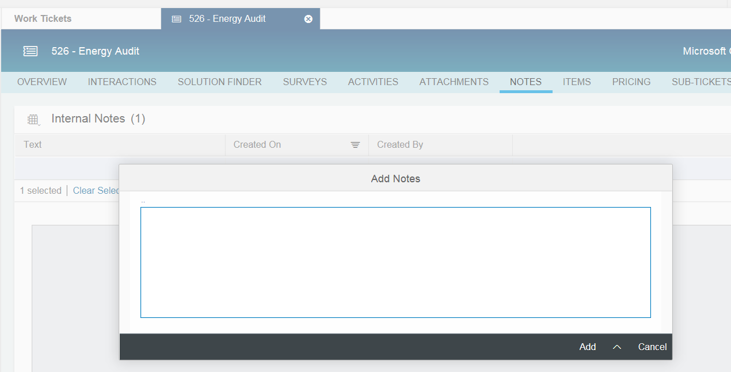
Figure 2.1.4.3.1 – ‘Notes’ facet on the ‘Work Tickets’ work center view
Dates: Customer Contact Date; Dispatched Date; Accepted Date; Technical Audit Date; Customer Received Report/ Letters Date and Audit Completion Date will be available for maintenance at the work ticket header level.
Partner Determination: When a Work Ticket is created as a follow-up transaction of a Lead or copied from another Work Ticket, partners assigned to party roles that are common to both transactions will be copied over to the Work Ticket transaction. If a Work Ticket is created without reference to a Lead or another Work Ticket, party roles: ‘Account Manger’ and ‘Employee Responsible’ will be automatically determined based on the Sales Territory ID determined for that transaction. Additionally, the following party roles will be available for manual maintenance in Work Tickets:
- Auditor
- Requestor
- SCE Field Engineer
- SCE Pump Test Engineer
- Primary Facility Contact
- Agent
Status: The following status codes will be available for selection in a work ticket: Open; In Process; Customer Action; Completed.
Attachments: Attachments can be added to a Work Ticket using the ‘Attachments’ facet as shown in Figure 2.1.4.3.2. A Local File or a Web Link or a file from the Library can be added as an attachment. For Energy Audit Work Tickets, ‘Standard Attachment’, ‘Audit Report’ and ‘Pump Test Letters’ will be defined as Dropdown List Values for the field: Attachment Type.
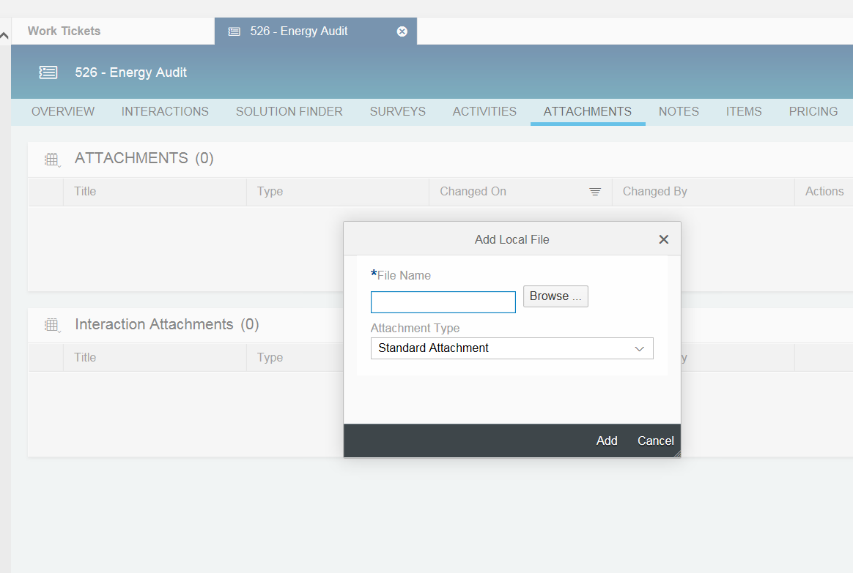
Figure 2.1.4.3.2 – ‘Attachments’ facet on the ‘Work Tickets’ work center view
Items: Measures that have been proposed to the customer will be added to the Work Ticket using the ‘Items’ facet. Item Number; Product ID; Product Description; Status; Quantity and Unit of Measure will be displayed in the ‘Items’ section of this facet.
Baseline Value; Installed Value; Energy Savings (KWH/ KW/ THERMS); Utilities Contract #; Validity (i.e.: Incentivized; Non-Incentivized) and Publish to Forecast will be added to the ‘General Data’ section at the line item level. The solution to populate these fields will be implemented through an enhancement. Refer to the FS: E-CIM-CS-16 - ‘Enhance the work ticket in SAP Hybris C4C with custom fields and business logic’ for more details.
Baseline Value: For Calculated Measures, this will be auto populated by the interface from OASIS. Additionally, user will have the ability to override this value in SAP Hybris C4C. For Deemed Measures, this is not applicable.
Installed Value: For Calculated Measures, this will be auto populated by the interface from OASIS. Additionally, user will have the ability to override this value in SAP Hybris C4C. For Deemed Measures, this is not applicable.
Energy Savings (KWH/ KW/ THERMS): For Deemed Measures, per unit Energy Savings (KWH/ KW/ THERMS) will be determined based on the information in a custom table. ‘Energy Savings (KWH)’, ‘Energy Savings (KW)’ and ‘Energy Savings (THERMS)’ will be determined using the formula: Energy Savings (KWH) = Energy Savings (KWH) per unit * Quantity; Energy Savings (KW) = Energy Savings (KW) per unit * Quantity; Energy Savings (THERMS) = Energy Savings (THERMS) per unit * Quantity. Refer to the FS: E-CIM-CS-16 – ‘Enhancement to calculate Energy Savings in an Opportunity and Work Ticket’ for more details.
For Calculated Measures, Energy Savings (KWH/ KW/ THERMS) will be calculated using the formula: Energy Savings (KWH) = Baseline Value (KWH) – Installed Value (KWH); Energy Savings (KW) = Baseline Value (KW) – Installed Value (KW); Energy Savings (THERMS) = Baseline Value (THERMS) – Installed Value (THERMS), where Baseline Value (KWH/ KW/ THERMS) and Installed Value (KWH/ KW/ THERMS) are entered manually on the corresponding line item. Refer to the FS: E-CIM-CS-16 – ‘Enhancement to calculate Energy Savings in an Opportunity and Work Ticket’ for more details.
Utilities Contract #, Validity and Include in Forecast fields will be manually entered by the user.
OASIS Integration: OASIS will be used to facilitate the execution of these energy audits. Therefore, upon request from OASIS, work tickets created in SAP Hybris C4C will be replicated to the OASIS system. Upon completion of energy audits in OASIS, these transactions will be replicated back to SAP Hybris C4C and corresponding work tickets will be updated with the results of the energy audit. The integration between SAP Hybris C4C and OASIS will be implemented through the following interfaces and enhancements:
Refer to the FS: I-CIM-CS-16 - ‘Interface to replicate Work Tickets from SAP Hybris C4C to OASIS’ for the solution to replicate energy audits from SAP Hybris C4C to OASIS.
Refer to the FS: I-CIM-CS-16 - ‘Interface to replicate Energy Audit Results from OASIS to SAP Hybris C4C’ for the solution to replicate energy audit results from OASIS to SAP Hybris C4C.
Refer to the FS: I-CIM-CS-16 - ‘Interface to download the contents of some custom master data tables from SAP Hybris C4C upon request from OASIS’ for the solution to replicate the contents of custom tables from SAP Hybris C4C to OASIS to support some capabilities within that tool.
Refer to the FS: I-CIM-CS-16 - ‘Interface to download the contents of some tables from SAP Hybris C4C upon request from OASIS to support the Wizard’ for the solution to replicate the contents of some tables from SAP Hybris C4C to OASIS to support the Wizard capabilities within OASIS.
Refer to the FS: I-CIM-CS-16 - ‘Interface to download ‘Pump Test’ data from SAP Hybris C4C to OASIS on a monthly basis’ for the solution to replicate the Pump Test data and facilitate the deletion of records that are more than 10 years old in OASIS.
Refer to the FS: E-CIM-CS-16 - ‘Enhancement to facilitate the storage and retrieval of custom master data in SAP Hybris C4C to support certain processes within OASIS’ for the solution to store custom master data to support some capabilities within OASIS and the Wizard feature.
A Rebate Program Opportunity can be created as a follow-up transaction of a Work Ticket. In this case, the following fields will be copied to the target transaction: Transaction Description; Account ID; Account Name; Multiple Utilities Contracts Indicator; Utilities Contract ID’s; Service Address(es); Tariff/ Rate Schedule; Facility Description; Building Type; NAICS Code; Industry; Climate Zone; Utilities Contract Usage; Average Cost/ kWh; Meter Number; Square Feet; Year Built; Direct Access; NEM Number; CCA Name; Pump Reference Number; Pump Name; Item Number; Product ID; Product Description; Quantity; Unit of Measure; Baseline Value; Installed Value; Energy Savings; Utilities Contract #; Validity; Parties Involved: Auditor, SCE Pump Test Engineer, SCE Field Engineer; and Attachments. The solution to copy energy audit details from the Work Ticket to Rebate Program Opportunity will be implemented through an enhancement. Refer to the FS: E-CIM-CS-16 – ‘Enhance the copy control logic for creating opportunities from work tickets’ for more details.
Audit Report: Upon completing the energy audit, users may generate the audit report by executing the action ‘Generate Audit Report’. Upon executing this action, the information needed to generate this report will be extracted from SAP Hybris C4C and exported to Open Text. This action will trigger the web service provided by Open Text to transfer information from SAP Hybris C4C to Open Text and provide a response back to SAP with the Open Text Archive Link and the status. The integration between SAP Hybris C4C and Open Text for generating the Audit Report will be implemented through an enhancement. Refer to the FS: E-CIM-CS-16 – ‘Enhance the Work Ticket to facilitate the generation of the Energy Audit Report’ for more details.
Copy: While creating a work ticket as a copy of another work ticket, the contents of most of the standard fields will be copied to the target transaction. In order to copy the contents of custom fields, the copy logic will be enhanced. Refer to the FS: E-CIM-CS-16 - ‘Enhance the copy control logic to copy custom attributes from a work ticket to a work ticket’ for more details. Upon copying the work ticket, a user will be able to change the Utilities Contract ID assigned to it and the system will automatically re-determine all work ticket attributes that are dependent on it. Refer to the FS: E-CIM-CS-16 - ‘Enhance the work ticket in SAP Hybris C4C with custom fields and business logic’ for more details.

      - Activity Management:
The Activity Management solution for Rebate Programs will be same as that of Customer Care. Refer to Section 2.1.1.3 for details.

    - Territory Management:
Territory Management can be used to organize sales markets into territories according to criteria such as geographical locations, customer segments, programs, and so on. This helps to determine who is responsible for a territory, which business partners belong to a territory, or which programs to offer in a territory. At SCE, sales territories will be defined according to customer segments.
The following are the main sub-processes within Territory Management:
    - Create/ Maintain Territory Hierarchy
    - Create/ Update Account Assignment
    - Create/ Update Employee Assignment
Create/ Maintain Territory Hierarchy:
Territory Hierarchy can be created in SAP Hybris C4C using ‘New Territory’ and ‘New Sub-Territory’ actions or in mass using the ‘Territories from Microsoft Excel’ action on the Territories work center view as shown below:
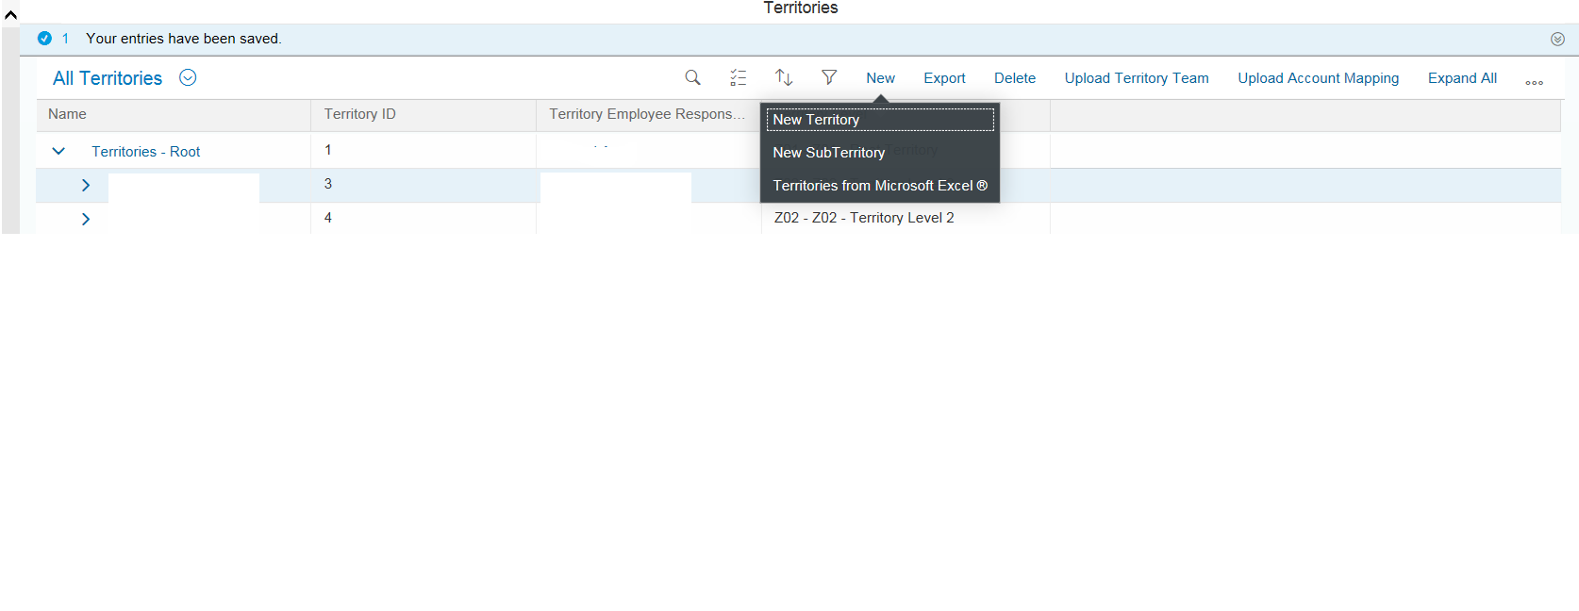
Figure 2.1.5.1 – Territories Work Center View in SAP Hybris C4C
Access to the ‘Territories’ work center view will be restricted to users who are assigned to the ‘Territory Professional’ business role.
The following Territory Hierarchy Levels will be defined in the SAP Hybris C4C system at SCE:
Level 0 – Root
Level 1 – Customer Service
Level 2 – Territory Type
Level 3 – Territory ID
Sales Territories will be defined according to the following customer segments:
S1 – Strategic Partner
S2 – Optimized Services
S4 – Self Service
HB – Home Builder
WG – Wholesale Generators
EC – Electric Service Provider/ Community Choice Aggregators
TP – Trade Professional
‘Segment Identifier’ will be defined as an attribute of an Account, and will contain a dropdown list of customer segment codes listed above.
While creating territories using ‘New Territory’ and ‘New Sub-Territory’ actions, Employee BP’s can be assigned to the following party roles:
- Account Manager
- Account Coordinator
- DER Specialist
- Inside Account Manager
Party Roles: Account Manager and Account Coordinator will be assigned to S1 territories, and will be auto-populated in all open transactions associated with accounts assigned to these territories.
Party Roles: Inside Account Manager and DER Specialist will be assigned to S2 territories, and will be auto-populated in all open transactions associated with accounts assigned to these territories.
Note: Open transactions include: Leads (i.e.: not yet converted), Opportunities (with status = Open or In Process or Stopped) and Activities (i.e.: Appointments, Phone Calls and Tasks with status = Open or In Process).
While creating territories using the ‘Territories from Microsoft Excel’ action, Employee BP’s can be assigned only to the ‘Employee Responsible – Sales’ party role.
Updates to the Territory Hierarchy can be requested by creating a Sales Task and assigning it to the Territory Management COE (i.e.: Organizational Unit: BCD – Territory Management). Territory Management COE personnel can update the Territory Hierarchy by creating new territories or reassigning or deleting existing territories. ‘New Territory’ and ‘New Sub-Territory’ actions can be used to create new territories and the ‘Delete’ action can be used to delete existing territories. Refer to figure 2.1.5.1 for a screenshot of ‘New Territory’, ‘New Sub-Territory’ and ‘Delete’ actions.
Create/ Update Account Assignment:
Accounts can be assigned to a territory or existing assignments can be updated manually on an individual basis by updating the ‘Territory ID’ field on the Account record, or in mass using the ‘Upload Account Mapping’ action on the ‘Territories’ work center view. New Assignments/ Updates to existing account-territory relationships will be requested by creating a Service Ticket and assigning it to the Territory Management COE. Upon successful verification of all approvals, Territory Management COE personnel will update the ‘Segment Identifier’ on the Account record if necessary, and then use one of the methods described above to create/ update account-territory relationships. All approvals will be attached to the Service Ticket submitted to the Territory Management COE.
The ‘Realignment’ process can be used to calculate account-territory relationships based on the rules for territory realignment. However, the account-territory mapping at SCE could not be represented as rules because of the nature of these assignments. Therefore, it was decided that the standard ‘Realignment’ process will not be used to create/ update these relationships and associated transactions.
In order to update all party roles/ partner functions that are determined based on the territory team in all open sales transactions associated with these records, a background job will be scheduled to run on a daily basis. This solution will be realized through an enhancement. Refer to the FS: E-CIM-CS-15 - ‘Enhancement to update all open transactions associated with account or individual customer records for which territory team was updated.’ for more information about this enhancement.
Note: Open transactions include: Leads (i.e.: not yet converted), Opportunities (with status = Open or In Process or Stopped) and Activities (i.e.: Appointments, Phone Calls and Tasks with status = Open or In Process).
Create/ Update Employee Assignment:
Employees can be assigned to territories or existing assignments can be updated manually on an individual basis using the actions on the ‘Territory Team’ facet of a territory record, or in mass using the ‘Upload Territory Team’ action on the ‘Territories’ work center view. Updates to the Territory Team will be requested by creating a Service Ticket and assigning it to the Territory Management COE. Upon successful verification of all approvals, Territory Management COE personnel will update the Territory Team using one of the methods described above. All approvals will be attached to the Service Ticket submitted to the Territory Management COE.
In order to update all party roles/ partner functions that are determined based on the territory team in all open sales transactions associated with these records, a background job will be scheduled to run on a daily basis. This solution will be realized through an enhancement. Refer to the FS: E-CIM-CS-15 - ‘Enhancement to update all open transactions associated with account or individual customer records for which territory team was updated.’ for more information about this enhancement.
Note: Open transactions include: Leads (i.e.: not yet converted), Opportunities (with status = Open or In Process or Stopped) and Activities (i.e.: Appointments, Phone Calls and Tasks with status = Open or In Process).

    - Reports:
      - CIM-CS-16-R0064: Ability to generate report based on detailed document flow data (example to demonstrate influence). – Action # 2284.
      - CIM-CS-16-R0102: Ability to report on Exceptions for Lead by type (TBD in design). – Action # 2316.
      - CIM-CS-16-R0103: Ability to report on Exceptions for Opportunities by type (TBD in design). – Action # 2318.
      - CIM-CS-16-R0105: Ability to report on Leads (all details). – Action # 2327.
      - CIM-CS-16-R0106: Ability to report on Opportunities (all details). – Action # 2328.
      - CIM-CS-16-R0128: Ability to generate a report containing Lead IDs, BP Name, BP ID, Lead Status (Won, Lost, In Process) within a user specified timeframe. – Action # 2873.
      - CIM-CS-16-R0129: All BCD reports should have the capability to include Director name, BP ID, Manager Name, BP ID, Account Manager Name, BP ID, Account Coordinator Name, BP ID, IDSM Specialist Name, BP ID, Inside Account Manager Name, BP ID, Economic Development consultant, BP ID, Economic Development Analyst, BP ID and (other defined personnel) for all transactions reports.
      - CIM-CS-16-R0130: Ability to generate a report containing Opportunity IDs, BP Name, BP ID, Estimated kWh Savings, Estimated kW Savings, Estimated Incentive Amount, Opportunity Status (Won, Lost, In Process) within a user specified timeframe. – Action # 2874.
      - CIM-CS-16-R0133: Lead report including all fields available on the Lead Transaction: Director; Manager; Account Manager; Account Manager BPID; Account Coordinator; Territory ID; Inside Account Manager; Inside Account Manager BPID; IDSM Specialist; IDSM Specialist BPID: Customer Name; Organization BPID; Contact Name; Contact BPID; Contract Name; Contract ID: Lead Type; Lead Status; Description (Title); Campaign ID; Qualification Level; Program ID; Origin; Priority; And other fields. - Action # 2875.
      - CIM-CS-16-R0134: Opportunity report including all fields available on the Opportunity Transaction: Director; Manager; Account Manager; Account Manager BPID; Account Coordinator; Territory ID; Inside Account Manager; Inside Account Manager BPID; IDSM Specialist; IDSM Specialist BPID: Customer Name; Organization BPID; Contact Name; Contact BPID; Contract Name; Contract ID: Opportunity Type; Opportunity Status; Description (Title); Campaign ID; Qualification Level; Program ID; Origin; Priority; and other fields. – Action # 2876.
      - CIM-CS-16-R0135: Ability on report on Lead Conversion to Opportunity to Contract. – Action # 2877.
      - CIM-CS-16-R0136: Ability to report on Lead Cycle Time by Status, Sales Stage, Employee Responsible. – Action # 2878.
      - CIM-CS-16-R0137: Ability to report on Opportunity Cycle Time by Status, Employee Responsible. – Action # 2880.
      - CIM-CS-16-R0139: Ability to generate EE Forecast reporting from DSM Opportunities. – Action # 2881.
      - CIM-CS-16-R0140: Ability to report on BCD KPI goal for Economic Development Services Jobs/kWh/kW (see existing Economic Development Services Opportunity report for detailed requirements). – Action # 2882.
      - CIM-CS-16-R0141: From AN-CI-01 - R0001 - Provide measure for Energy Efficiency programs (e.g. lighting, HVAC, etc.) For BCD, include information such as Measure Id & Description (reference to legacy system 'BCD EE Score Board Report'). Data is for the complete sales cycle. – Action # 2883.
      - CIM-CS-16-R0179: Ability to provide authorized users (leads / managers) with visibility, productivity reports, performance tracking both on-line views and printable reports in real time on leads.
      - CIM-CS-16-R0180: Ability to evaluate turnaround times from a lead creation to completion and determine days to complete by user, category, etc. – Action # 2884.
      - CIM-CS-16-R0187: Ability to provide authorized users (leads / managers) with visibility, productivity reports, performance tracking both on-line views and printable reports in real time on opportunities.
      - CIM-CS-16-R0188: Ability to evaluate turnaround times from a lead & opportunity creation to completion and determine days to complete by user, category, etc. – Action # 2885.
Note: Details pertaining to the reports listed above were requested and action Items were created in APSE to track the progress of this request. Based on the short description provided above, it appears that most of these reports have to be built in SAP BW/ BO.

Process / Performance Improvement
- Customer Care, Economic Development and New Construction Sales Cycle:
    - Interactions with customers through all channels will be logged in SAP Hybris C4C and as a result, sales personnel will have complete visibility to all customer interactions with SCE.
    - Sales Personnel can request COE’s or other departments for assistance creating Service Tickets, which can be assigned to other departments. This ensures a seamless integration between Sales and Service.
- Rebate Program Sales Cycle:
    - Energy Audit process will be simplified through the use of Work Tickets as opposed to Service Orders and Service Confirmations in LCRM. Moreover, the process to convert Work Tickets to Opportunities will be simplified through the use of Parent and Child Opportunities in SAP Hybris C4C.

Prerequisites and Inputs
- Master Data: Business Partners, Products, Territories, Prices exist in SAP Hybris C4C.
- SAP Hybris Marketing is integrated with SAP Hybris C4C to transfer leads.
  - SAP Hybris C4C is integrated with OASIS to support the Energy Audit process.
  - SAP Hybris C4C is integrated with iEnergy to support the creation of an application from a rebate program opportunity that is in ‘Won’ status.

General Assumptions
- Service Orders and Service Confirmations that are used in SAP CRM for Energy Audits will not be migrated to SAP Hybris C4C. Any open transactions will be created manually in SAP Hybris C4C during cutover.

Business Process Hierarchy
This Business Process Hierarchy provides a listing of all scenarios/business processes, sub-processes, and SAP Transaction codes identified to support this process.
Level 1 | Level 2 | Level 3 | Level 4
FO | Manage Leads, Opportunities and Territories | Manage Leads | Sales -> Leads
FO | Manage Leads, Opportunities and Territories | Manage Opportunities | Sales -> Opportunities
FO | Manage Leads, Opportunities and Territories | Manage Appointments | Activities -> Appointments
FO | Manage Leads, Opportunities and Territories | Manage E-Mails | Activities -> E-Mails
FO | Manage Leads, Opportunities and Territories | Manage Phone Calls | Activities -> Phone Calls
FO | Manage Leads, Opportunities and Territories | Manage Tasks | Activities -> Tasks
FO | Manage Leads, Opportunities and Territories | Manage Territories | Sales -> Territories
FO | Manage Leads, Opportunities and Territories | Manage Service Tickets | Service -> Tickets
FO | Manage Leads, Opportunities and Territories | Manage Work Tickets | Service -> Work Tickets

Process Flows
This BPD will cover 4 processes, including Customer Care Sales Cycle, Economic Development Sales Cycle, Demand Side Management Sales Cycle and New Construction Sales Cycle. Each subsection where the process is detailed will have a process flow diagram for that process and a table detailing the steps that are taken within that process including processes handled outside of SAP.

Customer Care Sales Cycle

Process Flow Diagram
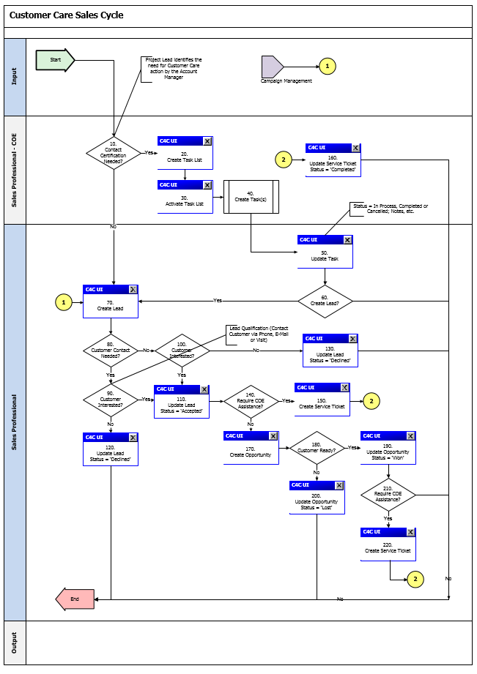

Process Flow Steps

Step | Description of Step | SAP Hybris C4C View / T-Code | Role(s) | If step is relevant for a Control, add Requirement ID
10 | Contact Certification Needed?  Project Lead identifies the need for Customer Care action by Sales personnel and submits a request to the COE to create tasks. | N/A | N/A | N/A
20 | Create Task List  COE personnel will create a Task List. | Activities Activity Lists | Sales Processional – COE | N/A
30 | Activate Task List  COE personnel will activate the Task List. | Activities Activity Lists | Sales Professional – COE | N/A
40 | Create Tasks  Activation of the Task List will trigger the creation of tasks. | Activities Tasks | Sales Professional – COE | N/A
50 | Update Task  Sales personnel will capture the actions taken to complete the task and update its status. | Activities Tasks | Sales Professional | N/A
60 | Create Lead?  Sales personnel will decide whether or not to create a lead. If a lead is required, proceed to step 70. If not, End. | N/A | Sales Professional | N/A
70 | Create Lead  Sales personnel will create a lead to capture customers intent to participate in or SCE’s intent to consider a customer for customer care initiatives. | Sales Leads | Sales Professional | N/A
80 | Customer Contact Needed?  Sales personnel will decide whether or not to contact the customer. If customer contact is needed, proceed to step 90. If not, proceed to step 100. | N/A | Sales Professional | N/A
90 | Customer Interested?  Sales personnel will determine customer’s level of interest in the Customer Care program. If the customer is interested, proceed to step 110. If not, proceed to step 120. | N/A | Sales Professional | N/A
100 | Customer Interested?  Sales personnel will determine customer’s level of interest in the Customer Care program. If the customer is interested, proceed to step 110. If not, proceed to step 130. | N/A | Sales Professional | N/A
110 | Update Lead Status = ‘Accepted’  Sales personnel will update the lead and set its status to ‘Accepted’. | Sales Leads | Sales Professional | N/A
120 | Update Lead Status = ‘Declined’  Sales personnel will update the lead and set its status to ‘Declined’. | Sales Leads | Sales Professional | N/A
130 | Update Lead Status = ‘Declined’  Sales personnel will update the lead and set its status to ‘Declined’. | Sales Leads | Sales Professional | N/A
140 | Require COE Assistance?  Sales personnel will determine whether or not COE assistance is needed. If COE assistance is needed, proceed to step 150. If not, proceed to step 170. | N/A | Sales Professional | N/A
150 | Create Service Ticket  Sales personnel will create a Service Ticket and assign it to the COE based on the nature of the request. | Service Tickets | Sales Professional | N/A
160 | Update Service Ticket Status = ‘Completed’  COE personnel will update the service ticket and set its status to ‘Completed’. | Service Tickets | Sales Professional – COE | N/A
170 | Create Opportunity  Sales personnel will create an opportunity. | Sales Opportunities | Sales Professional | N/A
180 | Customer Ready?  Sales personnel will determine whether or not the customer is ready to participate in the customer care initiative. If yes, proceed to step 190. If not, proceed to step 200. | N/A | Sales Professional | N/A
190 | Update Opportunity Status = ‘Won’  Sales personnel will update the opportunity and set its status to ‘Won’. | Sales Opportunities | Sales Professional | N/A
200 | Update Opportunity Status = ‘Lost’  Sales personnel will update the opportunity and set its status to ‘Lost’. | Sales Opportunities | Sales Professional | N/A
210 | Require COE Assistance?  Sales personnel will determine whether or not COE assistance is needed. If yes, proceed to step 220. If not, End. | N/A | Sales Professional | N/A
220 | Create Service Ticket  Sales personnel will create a Service Ticket and assign it to the COE based on the nature of the request. | Service Tickets | Sales Professional | N/A

Economic Development Sales Cycle

Process Flow Diagram
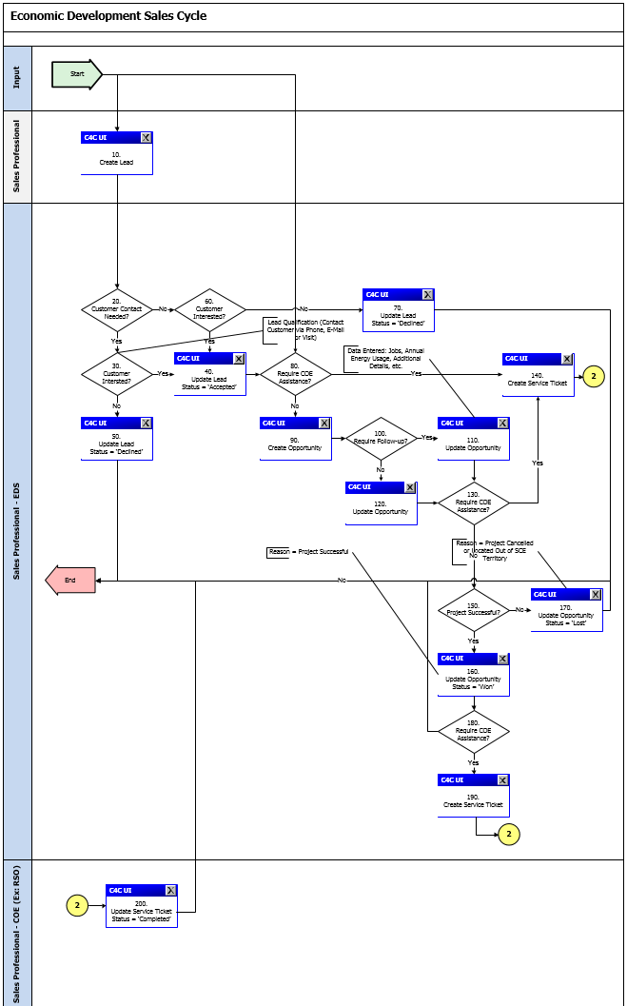

Process Flow Steps

Step | Description of Step | SAP Hybris C4C View / T-Code | Role(s) | If step is relevant for a Control, add Requirement ID
10 | Create Lead  Sales personnel create a lead to capture customer’s intent to participate in or SCE’s intent to consider a customer for Economic Development initiatives. | Sales Leads | Sales Professional | N/A
20 | Customer Contact Needed?  Economic Development Services personnel will determine whether or not to contact the customer. If customer contact is needed, proceed to step 30. If not, proceed to step 60. | N/A | Sales Professional | N/A
30 | Customer Interested?  Economic Development Services personnel will determine customer’s level of interest in the Economic Development program. If the customer is interested, proceed to step 40. If not, proceed to step 50. | N/A | Sales Professional | N/A
40 | Update Lead Status = ‘Accepted’  Economic Development Services personnel will update the lead and set its status to ‘Accepted’. | Sales Leads | Sales Professional | N/A
50 | Update Lead Status = ‘Declined’  Sales personnel will update the lead and set its status to ‘Declined’. | Sales Leads | Sales Professional | N/A
60 | Customer Interested?  Economic Development Services personnel will determine customer’s level of interest in the Economic Development program. If the customer is interested, proceed to step 40. If not, proceed to step 70. | N/A | Sales Professional | N/A
70 | Update Lead Status = ‘Declined’  Sales personnel will update the lead and set its status to ‘Declined’. | Sales Leads | Sales Professional | N/A
80 | Require COE Assistance?  Economic Development Services personnel will determine whether or not COE assistance is needed. If COE assistance is needed, proceed to step 140. If not, proceed to step 90. | N/A | Sales Professional | N/A
90 | Create Opportunity  Economic Development Services personnel will create an opportunity. | Sales Opportunities | Sales Professional | N/A
100 | Require Follow-up?  Economic Development Services personnel will determine whether a follow-up with the customer is needed. If so, proceed to step 110. If not, proceed to step 120. | N/A | Sales Professional | N/A
110 | Update Opportunity  Economic Development Services personnel will update the opportunity. | Sales Opportunities | Sales Professional | N/A
120 | Update Opportunity  Economic Development Services personnel will update the opportunity. | Sales Opportunities | Sales Professional | N/A
130 | Require COE Assistance?  Economic Development Services personnel will determine whether or not COE assistance is needed. If yes, proceed to step 140. If not, proceed to step 150. | N/A | Sales Professional | N/A
140 | Create Service Ticket  Economic Development Services personnel will create a Service Ticket and assign it to the COE based on the nature of the request. | Service Tickets | Sales Professional | N/A
150 | Project Successful?  If the Project was successful, proceed to step 160. If not, proceed to step 170. | N/A | Sales Professional | N/A
160 | Update Opportunity Status = ‘Won’  Economic Development Services personnel will update the opportunity and set its status to ‘Won’. | Sales Opportunities | Sales Professional | N/A
170 | Update Opportunity Status = ‘Lost’  Economic Development Services personnel will update the opportunity and set its status to ‘Lost’. | Sales Opportunities | Sales Professional | N/A
180 | Require COE Assistance?  Economic Development Services personnel will determine whether or not COE assistance is needed. If yes, proceed to step 190. If not, End. | N/A | Sales Professional | N/A
190 | Create Service Ticket  Economic Development Services personnel will create a Service Ticket and assign it to the COE based on the nature of the request. | Service Tickets | Sales Professional | N/A
200 | Update Service Ticket Status = ‘Completed’  COE personnel will update the service ticket and set its status to ‘Completed’. | Service Tickets | Sales Professional – COE | N/A

New Construction Sales Cycle

Process Flow Diagram
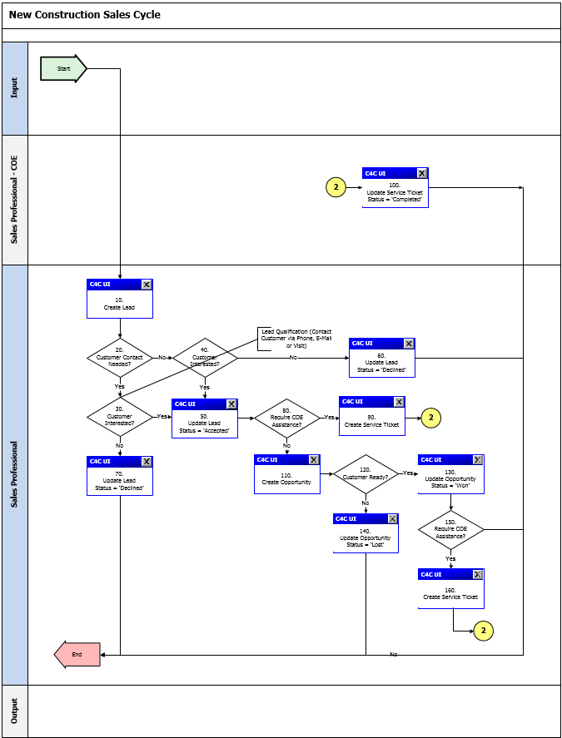

Process Flow Steps

Step | Description of Step | SAP Hybris C4C View / T-Code | Role(s) | If step is relevant for a Control, add Requirement ID
10 | Create Lead  Sales personnel will create a lead to capture customers intent to participate in or SCE’s intent to consider a customer for customer care initiatives. | Sales Leads | Sales Professional | N/A
20 | Customer Contact Needed?  Sales personnel will decide whether or not to contact the customer. If customer contact is needed, proceed to step 90. If not, proceed to step 100. | N/A | Sales Professional | N/A
30 | Customer Interested?  Sales personnel will determine customer’s level of interest in the Customer Care program. If the customer is interested, proceed to step 110. If not, proceed to step 120. | N/A | Sales Professional | N/A
40 | Customer Interested?  Sales personnel will determine customer’s level of interest in the Customer Care program. If the customer is interested, proceed to step 110. If not, proceed to step 130. | N/A | Sales Professional | N/A
50 | Update Lead Status = ‘Accepted’  Sales personnel will update the lead and set its status to ‘Accepted’. | Sales Leads | Sales Professional | N/A
60 | Update Lead Status = ‘Declined’  Sales personnel will update the lead and set its status to ‘Declined’. | Sales Leads | Sales Professional | N/A
70 | Update Lead Status = ‘Declined’  Sales personnel will update the lead and set its status to ‘Declined’. | Sales Leads | Sales Professional | N/A
80 | Require COE Assistance?  Sales personnel will determine whether or not COE assistance is needed. If COE assistance is needed, proceed to step 150. If not, proceed to step 170. | N/A | Sales Professional | N/A
90 | Create Service Ticket  Sales personnel will create a Service Ticket and assign it to the COE based on the nature of the request. | Service Tickets | Sales Professional | N/A
100 | Update Service Ticket Status = ‘Completed’  COE personnel will update the service ticket and set its status to ‘Completed’. | Service Tickets | Sales Professional – COE | N/A
110 | Create Opportunity  Sales personnel will create an opportunity. | Sales Opportunities | Sales Professional | N/A
120 | Customer Ready?  Sales personnel will determine whether or not the customer is ready to participate in the customer care initiative. If yes, proceed to step 190. If not, proceed to step 200. | N/A | Sales Professional | N/A
130 | Update Opportunity Status = ‘Won’  Sales personnel will update the opportunity and set its status to ‘Won’. | Sales Opportunities | Sales Professional | N/A
140 | Update Opportunity Status = ‘Lost’  Sales personnel will update the opportunity and set its status to ‘Lost’. | Sales Opportunities | Sales Professional | N/A
150 | Require COE Assistance?  Sales personnel will determine whether or not COE assistance is needed. If yes, proceed to step 220. If not, End. | N/A | Sales Professional | N/A
160 | Create Service Ticket  Sales personnel will create a Service Ticket and assign it to the COE based on the nature of the request. | Service Tickets | Sales Professional | N/A

Rebate Program Sales Cycle

Process Flow Diagram
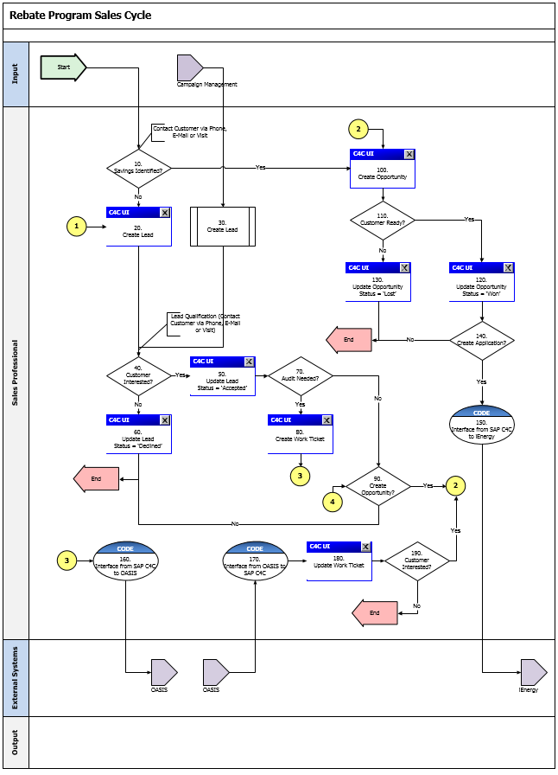

Process Flow Steps

Step | Description of Step | SAP Hybris C4C View / T-Code | Role(s) | If step is relevant for a Control, add Requirement ID
10 | Savings Identified?  Sales personnel will determine whether to create a Lead or an Opportunity. If savings for the rebate program are identified, proceed to step 100. If not, proceed to step 20. | N/A | Sales Professional | N/A
20 | Create Lead  Sales personnel create a lead to capture customer’s intent to participate in or SCE’s intent to consider a customer for Rebate Program initiatives. | Sales Leads | Sales Professional | N/A
30 | Create Lead  Leads generated from Marketing will be transferred to SAP Hybris C4C. | N/A | Sales Professional | N/A
40 | Customer Interested?  Sales personnel will determine customer’s level of interest in the Rebate program. If the customer is interested, proceed to step 50. If not, proceed to step 60. | N/A | Sales Professional | N/A
50 | Update Lead Status = ‘Accepted’  Sales personnel will update the lead and set its status to ‘Accepted’. | Sales Leads | Sales Professional | N/A
60 | Update Lead Status = ‘Declined’  Sales personnel will update the lead and set its status to ‘Declined’. | Sales Leads | Sales Professional | N/A
70 | Audit Needed?  Sales personnel will determine whether or not an Energy Audit is needed to proceed with the Rebate Program opportunity. If an Energy Audit is needed, proceed to step 80. If not, proceed to step 90. | N/A | Sales Professional | N/A
80 | Create Work Ticket  Sales personnel will create a Work Ticket as a follow-up of a Rebate Program Lead transaction. | Service Work Ticket | Sales Professional | N/A
90 | Create Opportunity?  Sales personnel will determine whether or not to create an opportunity. If an opportunity has to be created, proceed to step 100. If not, End. | N/A | Sales Professional | N/A
100 | Create Opportunity  Sales personnel will create an opportunity. | Sales Opportunities | Sales Professional | N/A
110 | Customer Ready?  Sales personnel will determine whether or not the customer is ready to move forward with the opportunity. If so, proceed to step 120. If not, proceed to step 130. | N/A | Sales Professional | N/A
120 | Update Opportunity  Sales personnel will update the opportunity. | Sales Opportunities | Sales Professional | N/A
130 | Update Opportunity  Sales personnel will update the opportunity. | Sales Opportunities | Sales Professional | N/A
140 | Create Application?  Sales personnel will determine whether or not to create an Application. If yes, proceed to step 150. If not, End. | N/A | Sales Professional | N/A
150 | Create an Application in iEnergy  Sales personnel will execute an action on the opportunity transaction in SAP Hybris C4C to trigger the creation of an application in iEnergy. | Sales Opportunities | Sales Professional | N/A
160 | Send Open Work Tickets from SAP Hybris C4C to OASIS in response to a request from OASIS  Upon receiving a request from OASIS, all Work Tickets matching the criteria specified in the request will be sent from SAP Hybris C4C to OASIS. | N/A | Sales Professional | N/A
170 | Send Completed Work Tickets from SAP OASIS to SAP Hybris C4C  Work Tickets that have been completed will be sent from OASIS to SAP Hybris C4C. | N/A | Sales Professional | N/A
180 | Update Work Ticket  Sales personnel will update the Work Ticket as needed | Service Work Ticket | Sales Professional | N/A
190 | Customer Interested?  Sales personnel will determine customer’s level of interest in the Rebate program. If the customer is interested, proceed to step 100. If not, End. | N/A | Sales Professional | N/A

3rd Party and SCE Legacy System Integrations

3rd Party or SCE Legacy System Integration | Description of Integration and Required Change to 3rd Party or SCE Legacy System | Estimated Complexity of 3rd Party or SCE Legacy system change
SAP Hybris C4C and MMDB | Initial Load of Measures from MMDB to SAP Hybris C4C  File structure has to be changed to conform to the ‘Products’ Data Migration Template.  Delta Load of Measures from MMDB to SAP Hybris C4C  File structure has to be changed to conform to the ‘Products’ Data Migration Template. | Medium
SAP Hybris C4C and OASIS | Replication of Work Tickets from SAP Hybris C4C to OASIS  Existing interface has to be updated to facilitate the replication of Energy Audits from SAP Hybris C4C to OASIS.  Replication of Energy Audits from OASIS to SAP Hybris C4C  Existing interface has to be updated to facilitate the replication of Energy Audit Results from OASIS to SAP Hybris C4C.  Interface to download the contents of some custom master data tables from SAP Hybris C4C upon request from OASIS  Existing interface has to be updated to facilitate the download of contents of some custom master data tables from SAP Hybris C4C to OASIS.  Interface to download the contents of some tables from SAP Hybris C4C upon request from OASIS to support the Wizard  Existing interface has to be updated to facilitate the download of contents of some custom master data tables from SAP Hybris C4C to OASIS to support the Wizard capabilities in OASIS.  Interface to download ‘Pump Test’ data from SAP Hybris C4C to OASIS on a monthly basis  Existing interface has to be updated to facilitate the download of ‘Pump Test’ data from SAP Hybris C4C to OASIS. | High
SAP Hybris C4C and iEnergy | Interface has to be developed to facilitate the creation of applications in iEnergy as follow-up transactions of opportunities in SAP Hybris C4C. | High

Data Elements
The information that will be captured for Leads, Opportunities, Activities and Work Tickets (either as part of migration or in the course of normal processing) will be defined in this section of the BPD.

Manual Entry
The following data elements will be available for maintenance in a Lead transaction:
Field | Type | Comments
Overview
Name | Required | Input Field
Account | Required | Input Field with Standard Search Help
Contact | Optional | Input Field with Standard Search Help
Qualification | Optional | Input Field with Dropdown List
Status | Required | Input Field with Dropdown List
Reason Code | Optional | Input Field with Dropdown List
Source | Optional | Input Field with Dropdown List
Start Date | Required | Input Field with Standard Search Help
End Date | Optional | Input Field with Standard Search Help
Campaign | Optional | Input Field with Standard Search Help
Category | Optional | Input Field with Dropdown List
Owner | Optional | Input Field with Standard Search Help
Sales Territory ID | Optional | Input Field with Standard Search Help
Products
Products |  | Table View:  (Product, Product Description, Product Category, Quantity and Unit of Measure)
Activities
Appointments |  | Table View:  (Subject, Status, Start Date/ Time and Owner)
Tasks |  | Table View:  (Subject, Status, Start Date/ Time and Owner)
Phone Calls |  | Table View:  (Subject, Status, Start Date/ Time and Owner)
E-Mails |  | Table View:  (Subject, Status, Start Date/ Time and Owner)
Contacts
Contacts |  | Table View:  (Name and Primary Contact)
Sales & Marketing Team
Sales & Marketing Team |  | Table View:  (Party Role, Name and Primary)
Involved Parties
Involved Parties |  | Table View:  (Party Role, Name and Primary)
Attachments
Attachments |  | Table View:  (File Name and Attachment Type)
Notes
Notes |  | Text Box

      - Source Systems and Data Volumes
Identify the historical amount, volume, and Southern California Edison source systems for data objects supporting this process. The expected annual growth rate is [percent growth]%, for another [number of records] to be added to SAP per annum.
N/A

Manual Entry
The following data elements will be available for maintenance in Customer Care and Economic Development Opportunities:
Field | Type | Comments
Overview
Name | Required | Input Field
Account | Required | Input Field with Standard Search Help
Contact | Optional | Input Field with Standard Search Help
Status | Required | Input Field with Dropdown List
Reason for Status | Optional | Input Field with Dropdown List
Source | Optional | Input Field with Dropdown List
Sales Cycle | Required | Input Field with Dropdown List
Sales Phase | Required | Input Field with Dropdown List
Start Date | Required | Input Field with Standard Search Help
Close Date | Optional | Input Field with Standard Search Help
Campaign | Optional | Input Field with Standard Search Help
Category | Optional | Input Field with Dropdown List
Owner | Optional | Input Field with Standard Search Help
Sales Territory ID | Optional | Input Field with Standard Search Help
Probability | Optional | Input Field
Expected Value | Optional | Input Field
Utilities Contracts | Optional | Table View:  (Utilities Contract ID)
Topics Covered | Optional | Table View:  (Topic, Sub-Topic)
Additional Details | Optional | Table View:  (Value, Description)
Products
Products |  | Table View:  (Product, Product Description, Product Category, Quantity and Unit of Measure)
Sales Activities
Appointments |  | Table View:  (Subject, Status, Start Date/ Time and Owner)
Tasks |  | Table View:  (Subject, Status, Start Date/ Time and Owner)
Phone Calls |  | Table View:  (Subject, Status, Start Date/ Time and Owner)
E-Mails |  | Table View:  (Subject, Status, Start Date/ Time and Owner)
Contacts
Contacts |  | Table View:  (Name and Primary Contact)
Sales Team
Sales Team |  | Table View:  (Party Role, Name and Primary)
Involved Parties
Involved Parties |  | Table View:  (Party Role, Name and Primary)
Attachments
Attachments |  | Table View:  (File Name and Attachment Type)
Notes
Notes |  | Text Box

      - Source Systems and Data Volumes
Identify the historical amount, volume, and Southern California Edison source systems for data objects supporting this process. The expected annual growth rate is [percent growth]%, for another [number of records] to be added to SAP per annum.
N/A

Manual Entry
The following data elements will be available for maintenance in New Construction and Rebate Program Opportunities:
Field | Type | Comments
Overview
Name | Required | Input Field
Account | Required | Input Field with Standard Search Help
Contact | Optional | Input Field with Standard Search Help
Status | Required | Input Field with Dropdown List
Reason for Status | Optional | Input Field with Dropdown List
Source | Optional | Input Field with Dropdown List
Sales Cycle | Required | Input Field with Dropdown List
Sales Phase | Required | Input Field with Dropdown List
Start Date | Required | Input Field with Standard Search Help
Close Date | Optional | Input Field with Standard Search Help
Campaign | Optional | Input Field with Standard Search Help
Category | Optional | Input Field with Dropdown List
Owner | Optional | Input Field with Standard Search Help
Sales Territory ID | Optional | Input Field with Standard Search Help
Probability | Optional | Input Field
Expected Value | Optional | Input Field
Influence | Optional | Input Field with Dropdown List
Market Identifier | Optional | Input Field with Dropdown List
Program ID | Optional | Input Field with Search Help
Utilities Contracts | Optional | Table View:  (Utilities Contract ID)
Topics Covered | Optional | Table View:  (Topic, Sub-Topic)
Additional Details | Optional | Table View:  (Value, Description)
Products
Products |  | Table View:  (Product, Product Description, Product Category, Quantity and Unit of Measure)
Sales Activities
Appointments |  | Table View:  (Subject, Status, Start Date/ Time and Owner)
Tasks |  | Table View:  (Subject, Status, Start Date/ Time and Owner)
Phone Calls |  | Table View:  (Subject, Status, Start Date/ Time and Owner)
E-Mails |  | Table View:  (Subject, Status, Start Date/ Time and Owner)
Contacts
Contacts |  | Table View:  (Name and Primary Contact)
Sales Team
Sales Team |  | Table View:  (Party Role, Name and Primary)
Involved Parties
Involved Parties |  | Table View:  (Party Role, Name and Primary)
Attachments
Attachments |  | Table View:  (File Name and Attachment Type)
Notes
Notes |  | Text Box

      - Source Systems and Data Volumes
Identify the historical amount, volume, and Southern California Edison source systems for data objects supporting this process. The expected annual growth rate is [percent growth]%, for another [number of records] to be added to SAP per annum.
N/A

Cloud for Customer (C4C) Integration

Processes
- Manage Leads
- Manage Opportunities
- Manage Activities
- Manage Territories
- Manage Service Tickets
- Manage Work Tickets

C4C Views
- Sales Leads
- Sales Opportunities
- Sales Activities
- Sales Territories
- Service Service Tickets
- Service Work Tickets

Interaction Records
N/A

Exception Management Requirements
This section outlines a high level description of each BPEM Case or other user workflow items (such as “Tickets” used by Front Office) used to route work requests between business areas. The companion document for this section which outlines the detail of each case is documented in APSE on the Exception Case Template General Document #8.
User Exception Scenario / Description | User Group | Initiated by | Work Distribution
Request Rate Change (i.e.: EDR) | RSO – Billing | Economic Development Services

Process Risks and Mitigation
N/A

Key Performance Indicators
The following have been identified as KPI’s at Southern California Edison, along with the means of measuring each KPI and the current measurement statistic for each KPI:
Measured KPI | Description | Measurement Method | Current Statistic
N/A | N/A | N/A | N/A

Key Metric Definition
The following have been identified as key metrics at Southern California Edison that require business rule for calculation:
Key Metric | Description | Business Rule | Reference
N/A | N/A | N/A | N/A

Controls, Regulatory Rules, and Security
Requirement ID  (from RTM) | Requirement Description | Requirement Type (Business Rule, Control Audit, Legal/Regulatory) | Additional Details  (e.g. SoX, COSO, CPUC, FERC, NERC)
N/A | N/A | N/A | N/A

Security Considerations
Role | Transaction Code (T-Code) / Work center -> View Name | T-Code Description/ View Description | Authorization Attributes | SOD Conflicts (Yes/No)  If SOD Conflicts Yes. Identify the 2 conflicting t-codes
Sales Professional – COE | Sales -> Leads | Leads | N/A | N/A
Sales Professional – COE | Sales -> Opportunities | Opportunities | N/A | N/A
Sales Professional – COE | Activities -> Appointments | Appointments | N/A | N/A
Sales Professional – COE | Activities -> E-Mails | E-Mails | N/A | N/A
Sales Professional – COE | Activities -> Phone Calls | Phone Calls | N/A | N/A
Sales Professional – COE | Activities -> Tasks | Tasks | N/A | N/A
Sales Professional – COE | Service -> Tickets | Service Tickets | N/A | N/A
Sales Professional – COE | Mass Data Maintenance | Mass Data Maintenance | N/A | N/A
Sales Professional | Sales -> Leads | Leads | N/A | N/A
Sales Professional | Sales -> Opportunities | Opportunities | N/A | N/A
Sales Professional | Activities -> Appointments | Appointments | N/A | N/A
Sales Professional | Activities -> E-Mails | E-Mails | N/A | N/A
Sales Professional | Activities -> Phone Calls | Phone Calls | N/A | N/A
Sales Professional | Activities -> Tasks | Tasks | N/A | N/A
Sales Professional | Service -> Tickets | Service Tickets | N/A | N/A
Sales Professional | Service -> Work Tickets | Work Tickets | N/A | N/A
Territory Professional | Sales -> Territories | Territories | N/A | N/A
Territory Professional | Mass Data Maintenance | Mass Data Maintenance | N/A | N/A

Custom Program/Transaction Codes
Custom Program | Authorization Grp | Custom T-code | Authorization Object used in the authorization check statement
N/A | N/A | N/A | N/A

Custom Table/Transaction Codes
Custom Table | Authorization Grp Assigned | Custom T-code for the Table | Table Access (display/update)
N/A | N/A | N/A | N/A

Technical Considerations

RICEF-W Assessment

Reports
Report Name & Description (List Requirements met by this Report) | Complexity | Reference ID
N/A | N/A | N/A

Interfaces
Interface Name & Description (List Requirements met by this Interface) | Complexity | Reference ID
Interface to replicate work tickets from SAP Hybris C4C to OASIS | Complex | APSE # 1594: Interface to replicate work tickets from SAP Hybris C4C to OASIS
Interface to download the contents of some custom master data tables from SAP Hybris C4C upon request from OASIS | Medium | APSE # 1595: Interface to download the contents of some custom master data tables from SAP Hybris C4C upon request from OASIS
Interface to replicate energy audit results from OASIS to SAP Hybris C4C | Complex | APSE # 1596: Interface to replicate energy audit results from OASIS to SAP Hybris C4C
Interface to download the contents of some tables from SAP Hybris C4C upon request from OASIS to support the Wizard | Medium | APSE # 2038:  Interface to download the contents of some tables from SAP Hybris C4C upon request from OASIS to support the Wizard
Interface to download ‘Pump Test’ data from SAP Hybris C4C to OASIS on a monthly basis | Medium | APSE # 2039:  Interface to download ‘Pump Test’ data from SAP Hybris C4C to OASIS on a monthly basis
Interface to replicate new measures or changes to existing measures from MMDB to SAP Hybris C4C | Medium | APSE # 2040: Interface to replicate changes to measures from MMDB to SAP Hybris C4C

Conversion
Conversion Name & Description (List Requirements met by this Conversion) | Complexity | Reference ID
Measures and Products | Medium | APSE # 2041: Convert measures from MMDB to SAP C4C
Leads | Medium | APSE # 1592: Convert all active Leads from legacy CRM to Hybris C4C
Opportunities | Complex | APSE # 1593: Convert all active Opportunities from legacy CRM to Hybris C4C
Activities | Medium | APSE # 31: Sales Activities
Territories | Simple | APSE # 30: Territories
Attachments for Activities, Tasks and Opportunities | Medium | APSE # 32: Attachments for Activities, Tasks and Opportunities

Extension/Enhancements
Extension Name & Description (List Requirements met by this Extension) | Complexity | Reference ID
Enhancement to update all open transactions associated with account or individual customer records for which territory team was updated | Complex | APSE # 1416: Enhancement to update all open transactions associated with account or individual customer records for which territory team was updated
Enhance the search criteria and results list for leads | Medium | APSE # 1419: Enhance the search criteria and results list for leads
Enhance leads in SAP Hybris C4C with custom fields and business logic | Medium | APSE # 1580: Enhance leads in SAP Hybris C4C with custom fields and business logic
Enhance non-rebate program opportunities in SAP Hybris C4C with custom fields and business logic | Complex | APSE # 1581: Enhance non-rebate program opportunities in SAP Hybris C4C with custom fields and business logic
Enhance the copy control logic for creating opportunities from work tickets | Medium | APSE # 1583: Enhance the copy control logic for creating opportunities from work tickets
Enhance the search criteria and results list for opportunities | Medium | APSE # 1585: Enhance the search criteria and results list for opportunities
Enhance rebate program and new construction opportunities in SAP Hybris C4C with custom fields and business logic | Complex | APSE # 1587: Enhance rebate program and new construction opportunities in SAP Hybris C4C with custom fields and business logic
Enhancement to update the status of leads and opportunities in mass | Medium | APSE # 1589: Enhancement to update the status of leads and opportunities in mass
Enhancement to calculate Energy Savings in an Opportunity and Work Ticket | Complex | APSE # 1590:  Enhancement to calculate Energy Savings in an Opportunity and Work Ticket
Enhance the copy control logic for creating opportunities from leads | Medium | APSE # 1834: Enhance the copy control logic for creating opportunities from leads
Enhance the copy control logic to copy custom attributes from an opportunity to another opportunity | Medium | APSE # 2043: Enhance the copy control logic to copy custom attributes from an opportunity to another opportunity
Enhance the Rebate Program Opportunity to trigger the creation of an application in iEnergy from SAP Hybris C4C | Medium | APSE # 2044: Enhancement to trigger the web service to create an application in iEnergy from an opportunity in SAP Hybris C4C
Enhance Energy Audit Work Tickets in SAP Hybris C4C with custom fields and business logic | Complex | APSE # 2045:  Enhance the work ticket in SAP Hybris C4C with custom fields and business logic
Enhancement to facilitate the storage and retrieval of custom master data in SAP Hybris C4C to support certain processes within OASIS | Complex | APSE # 2046:  Enhancement to facilitate the storage and retrieval of custom master data in SAP Hybris C4C to support certain processes within OASIS
Enhance the copy control logic to copy custom attributes from a work ticket to another work ticket | Medium | APSE # 2047: Enhance the copy control logic to copy custom attributes from a work ticket to another work ticket
Enhance the work ticket to facilitate the generation of the Energy Audit Report | Medium | APSE # 2048:  Enhance the work ticket to facilitate the generation of the Energy Audit Report

Forms
Form Name & Description (List Requirements met by this Form) | Complexity | Reference ID
N/A | N/A | N/A

Workflows
Workflow Name & Description (List Requirements met by this Workflow) | Complexity | Reference ID
N/A | N/A | N/A

IDEX Considerations
N/A

Production System Cut-over Considerations
- Replicate Business Partners to from SAP S/4 HANA to SAP Hybris C4C
- Migrate Measures and Products to SAP Hybris C4C
- Migrate Leads, Opportunities, Activities to SAP Hybris C4C
- Migrate Territory Hierarchy to SAP Hybris C4C
- Migrate Organizational Structure to SAP Hybris C4C

Other Considerations
N/A

Change Management

Change Impacts

Change Element Short Description | Change Impact Category | Audience Group(s) | Impact | Business Effort
DSM and Energy Savings programs process may change based on the new bolt on process integration. The lead/opportunity process will change as a result of outputs from the bolt on system. SAP front office User Interface will have an integration with the new bolt on systems. Currently DSM opportunities are created and tracked in the Legacy CRM system. | Culture Shift;Process;Technology;Improvement (517) | CS-BCD-All;CS-CSOD-CCC-PS;CS-CSOD-CCC-EE | High | Medium
The NAICS code is entered in the BP and/or the Opportunity. Authorized Users will have the ability to manually update the opportunity NAICS codes (without updating the BP). Provides the ability to track industries engaging with SCE programs. Currently only Consumer Affairs updates NAICS codes. In the future, authorized users will have the ability to update the NAICS code in the opportunity. Users will need the appropriate training on the process to ensure that the appropriate code is added. | Process;Decision Making (962) | CS-BCD-All | Low | Low
Today there is a mass functionality capability to manage leads. In the new system users will use workflow builder to set rules to update leads. This a benefit with a more streamlined approach. | Process;Decision Making;Improvement (973) | CS-BCD-All | Medium | Medium
CCC can create a ticket to capture interest in products/programs to BCD COE such as Small Business requests etc. Currently these requests are issued as a note on the account and is emailed to the COE for customer contact. The process will need to be created to determine what is needed on the ticket and what other programs can be used by our commercial agents. | Improvement;Process (1116) | CS-BCD-All;CS-CSOD-CCC-C&I | Low | Low
Currently users select opportunity item level measures via check box and that will be replaced by user creating “sub-opportunity” by copying from "master" opportunity and selecting items/measures progressing in sales cycle to application. | Improvement;Process (1150) | CS-BCD-All | Medium | Medium
Today users create a service order and service confirmation to request/complete an energy audit. Users will create a work ticket to request and track completion of an energy audit in the new system. Users will need to be trained on how to complete the work ticket and the different statuses for tracking purposes. | Improvement;Process (1151) | CS-BCD-All | Medium | Medium

Below is a description of each:
Change Element Short Description: Describes the ‘As-Is’ scenario and what is changing.
Change Impact Category: Determined by asking the questions below.
- Staffing Levels - Is the work effort increasing or decreasing (staffing levels), and how (e.g., task automation, new process/tasks)?
- Job Roles - Will the responsibilities, authority, or required skills for a job or job roles change? Will people be reporting to new leaders? Will managers’ responsibilities change?
- Compensation / Performance - Will the changes have such an impact on roles of an individual that merits a change in how they are compensated or how their performance will be evaluated? What behaviors are rewarded and recognized?
- Organization Structure - Is the ownership of the Process or Data changing (think departments, jobs, or roles, not individuals)?
- Decision Making - Will any of the changes impact how decisions are made, by or between, business units / departments? Who makes them, how they determine the criteria for making a change?
- Culture Shift - Will organizational value systems impact the way change happens or be impacted by the change? What are the underlying values of the organization that will directly influence the way change will be accepted and how much work will ultimately be required to ensure successful outcomes for the business?
- Location / Facilities - Will the change impact the physical location where they process is being implemented or require changes to the facilities to enable the process to be effective?
- Process - Any change to the current process (e.g. manual process becomes automatic, or vice versa)? Are there new processes being introduced or an old process being decommissioned? Is there a requirement to change an existing business rule or business policy? Will new business rule or policy needs to be introduced and enforced or complied to?
- Regulatory/ Legal - Are there any legal / regulatory requirements that might be impacted
- Technology - Are other applications impacted (e.g., going away, becoming read-only), or are there new requirements (e.g., new SW / HW, new version)
- Benefit/Improvement - Will there be an improvement or benefit to any of the stakeholders because of this change. (Be sure to include any pain points that are being alleviated)
- Other - Are there emotional implications stemming from any of these changes (think of buy-in issues or fears)
Audience Group(s): These are the affected departments, divisions etc…
Impact: The following were used to determine the impact:

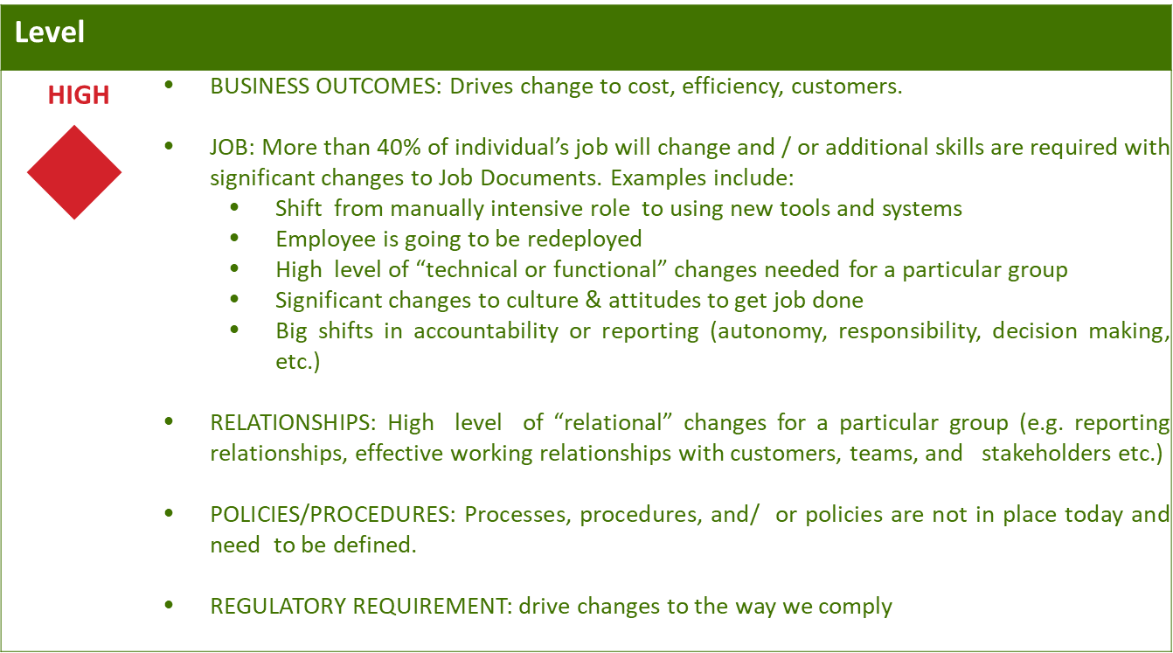
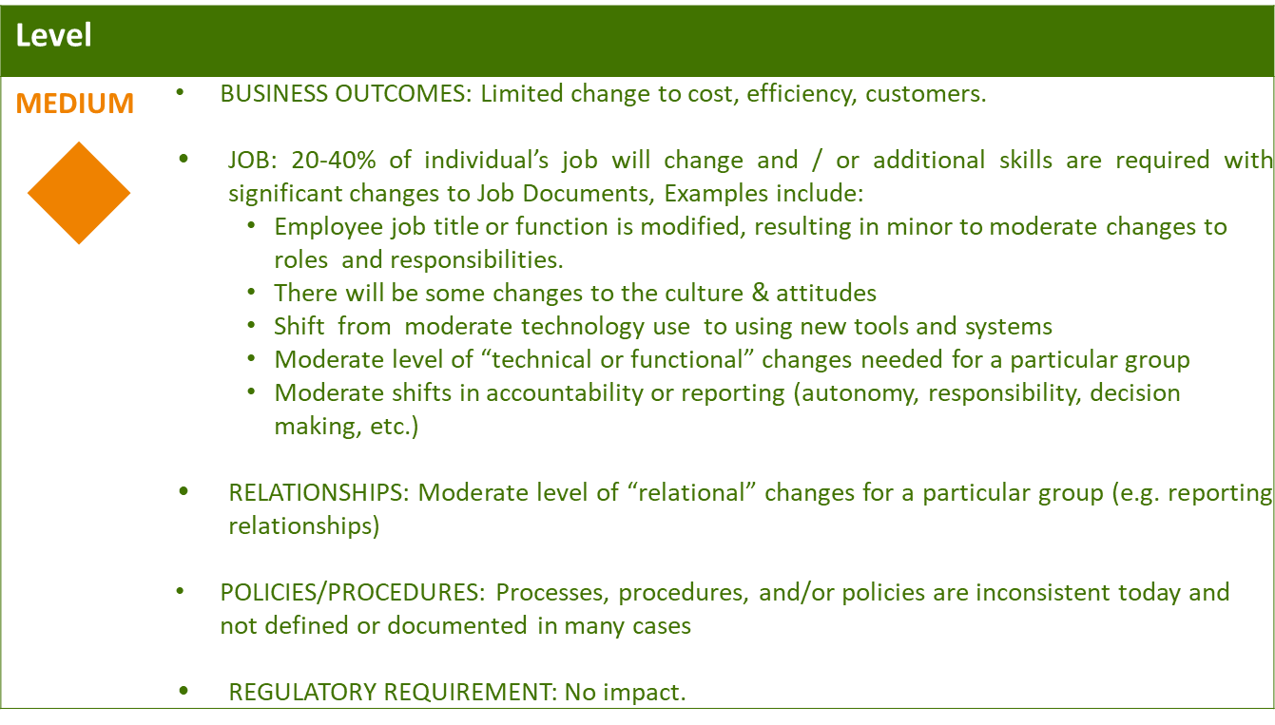
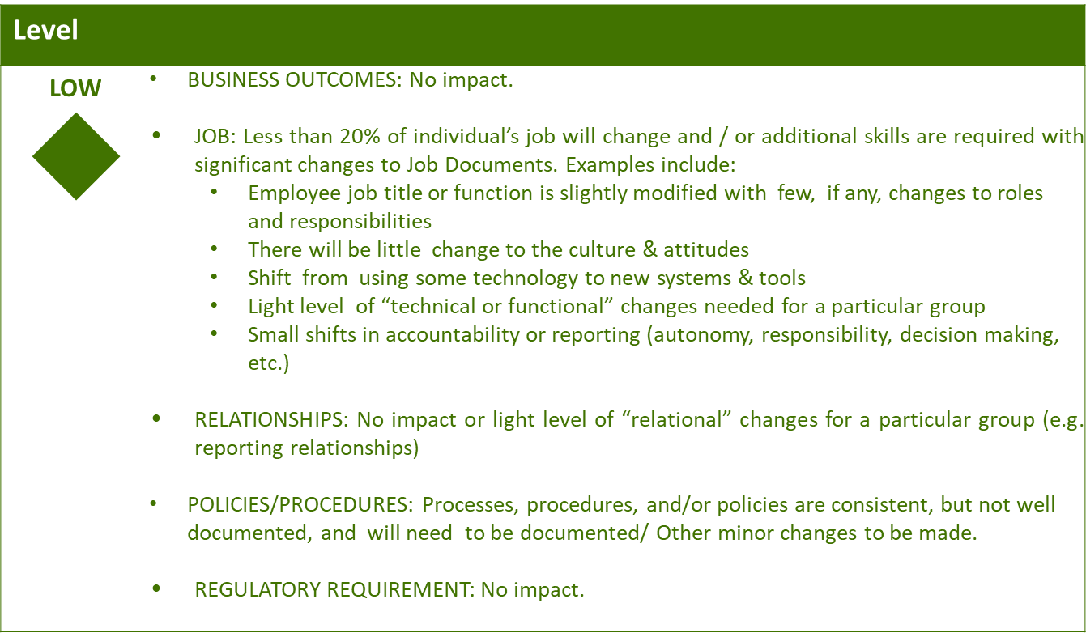

Business Effort: Initial assessment of the impact to the business High, Medium, Low

Requirements

